

Master Thesis

Master of Science (M.sc)
Department of Business
Major: Data Science (DS)

Topic: Business Improvement Using Marketing Analysis: Optimized Recommendation Systems Using Machine Learning

Author: Ayda Mokhtarzadeh
Matriculation-Number: 87059554
First supervisor: Prof. Dr Talha Ali Khan
Second supervisor: Prof. Dr Iftikhar Ahmed

Submitted on: 27-02-2025

EIGENSTÄNDIGKEITSERKLÄRUNG / STATEMENT OF AUTHORSHIP

1
Name | Family Name Vorname | First Name

Matrikelnummer | Student ID Titel der Examsarbeit | Title of Thesis Number
Ich versichere durch meine Unterschrift, dass ich die hier vorgelegte Arbeit selbstständig verfasst habe. Ich habe mich dazu keiner anderen als der im Anhang verzeichneten Quellen und Hilfsmittel, insbesondere keiner nicht genannten Onlinequellen, bedient. Alles aus den benutzten Quellen wörtlich oder sinngemäß übernommen Teile (gleich ob Textstellen, bildliche Darstellungen usw.) sind als solche einzeln kenntlich gemacht.
Die vorliegende Arbeit ist bislang keiner anderen Prufungsbeh.rde vorgelegt worden. Sie war weder in gleicher noch ̈ in ähnlicher Weise Bestandteil einer Prufungsleistung im bisherigen Studienverlauf und ist auch noch nicht publiziert. ̈ Die als Druckschrift eingereichte Fassung der Arbeit ist in allen Teilen identisch mit der zeitgleich auf einem elektronischen Speichermedium eingereichten Fassung.
With my signature, I confirm to be the sole author of the thesis presented. Where the work of others has been consulted, this is duly acknowledged in the thesis‘bibliography. All verbatim or referential use of the sources named in the bibliography has been specifically indicated in the text.
The thesis at hand has not been presented to another examination board. It has not been part of an assignment over my course of studies and has not been published. The paper version of this thesis is identical to the digital version handed in.

Datum, Ort | Date, Place Unterschrift | Signature

Abstract
The present work has found that the implementation of machine learning (ML) in the field of marketing has changed the way that organizations enhance their advertising and campaign efforts. Due to the rapid development of digital marketing and its undeniable impact on businesses and business-customer relationships, companies are more likely to use predictive analytics and social media performance analysis in their marketing campaigns to improve the return on investment (ROI) and boost customer interaction in a more effective way. As the availability of various social media platforms increases, businesses face the challenge of identifying the best channel for each product category, advertisement, and campaign to maximize impact and customer engagement. This is unlike traditional marketing strategies where decisions are made based on assumptions or historical performance without real-time insights. The ML-driven analytics help marketers make decisions on ad placement and targeting based on real-time performance. This study focuses on determining the best social media platform for different product categories using AI-based decision-making models.

This paper proposes an ML-based recommendation system that can assist in identifying the right social media platforms for promoting different product categories based on performance indicators such as impressions, ROI, engagement score, conversion rate, and click-to-buy rate. This study develops a random forest-based classification model to assist firms in making data-driven decisions and ensuring that advertising budgets are allocated effectively to reduce waste. (The mention of decision trees has been removed since your methodology focuses only on Random Forest.)

Machine learning has transformed digital advertising by enabling businesses to use scientific data-driven approaches to deliver effective customer targeting while transforming how marketing strategies are developed. Through the application of ML algorithms, companies can study consumer behavior, identify trends, and automate decision-making to maximize marketing efficiency while reducing costs. With this shift, companies can move away from intuitive marketing approaches toward structured methods that optimize ad placement and campaign tactics for better results. Because machine learning models operate through constant learning and adaptation, marketing efforts become dynamically optimized through the analysis of historical advertising performance data and customer interactions.

Customer segmentation and product category classification are critical in AI-driven marketing strategies. Instead of using clustering techniques such as k-means or hierarchical clustering, this study encodes customer segments numerically to assess the most effective social media platform for each segment. The recommendation system evaluates engagement levels, click-to-buy ratios, and conversion rates to determine where each product category achieves the best results. This segmentation enables businesses to ensure that advertisements are placed on the most relevant platforms, maximizing engagement and conversion rates. Furthermore, analyzing real-time performance metrics enhances the ability to predict customer responses and optimize budget allocation efficiently.

Furthermore, social media platform analysis enables businesses to align their marketing strategies with platform effectiveness by evaluating key performance indicators such as engagement score and ROI. Some platforms, including Instagram and TikTok, are identified as high-performing channels for visually driven products such as fashion and beauty, whereas platforms like LinkedIn are more suitable for B2B marketing and professional services. This research provides a data-based approach to platform selection, ensuring that companies make advertising decisions based on evidence rather than subjective preference.

To validate the efficiency of the recommendation system, accuracy scores from the Random Forest model and feature importance analysis are used to evaluate the model’s ability to recommend the most suitable advertising platform for a given product category. This ensures that the model’s performance is interpreted based on its predictive accuracy and the relative influence of key marketing factors.
This study aims to achieve an improvement in marketing performance in comparison with previous ways of marketing analysis. This study is to try to make a different way of marketing analysis to replace usual AI-based marketing approaches using product categories to find the best social media for marketing effort on it. In this project ROI(Return On Investment) is used to determine marketing performance in each category in the social media which it got advertised.

Moreover, in comparison with traditional marketing analysis ways, this project helps to understand how AI-based recommendations can boost return on investment in marketing activities.
The performance of this system has been measured by analyzing engagement rates, click-through rates, and social media-specific performance trends.
This research suggests that a recommendation system based on marketing performance in each category can enhance effectiveness of marketing efforts and lead the marketing activities to a more effective and budget friendly way (William, 2024).

These results are in the same way with this study which is to show that replacement of decision-making based on general insight can have better performance if be replaced with data-driven decision-making.
Focusing on the real-time data and analysis of each social media for advertising and other marketing activities helps in targeting the audience in the most effective way and prevents from wasting investment. based evaluation, this model ensures that marketing efforts are optimized based on data-driven segmentation and platform-specific outcomes.

Therefore, using machine learning in the management of advertising can be described as a company’s purpose to develop an effective and reasonable approach to marketing.
Thus, ensuring that every product is promoted on the right channel, companies can avoid the situation where they use money to advertise their products on the wrong platforms and get a high return on investment at the same time.
Moreover, decreasing the number of ineffective advertising placements helps the businesses to enhance the effectiveness of the campaigns in the already crowded digital environment. Therefore, the results of this study show that decision-making with the help of ML can increase customer retention and reduce the costs of advertising by suggesting the most appropriate channel for each product.
However, the use of AI improves the marketing processes, there are still some concerns such as ethical issues including data collection and the understanding of the algorithms used.
It is, therefore, important for businesses to practice responsible data management to prevent biases in the recommendation systems and to build the trust of consumers.
The development of ethical standards for the use of AI in marketing guarantees that consumers’ data is processed properly, and the choice of platforms is made about their effectiveness. In conclusion, this paper proposes a systematic approach to using AI to determine the most suitable social media platforms for advertising various product categories. With the use of performance data, consumer engagement patterns and predictive analysis, the suggested recommendation system is useful in helping digital marketers in achieving better results from their marketing campaigns.
To survive in the modern market where everything is based on data, digital marketing teams must consist in the use of AI tools in their plans. Thus, the AI models assist the marketers in identifying the important features and the performance of the campaigns to improve the effectiveness of the campaigns and the allocation of the budget.
The development of the recommendation system based on machine learning ensures that businesses will focus on the platforms that will bring the most return on investment for their advertising efforts in each product category.
The advancement of machine learning systems enables digital marketers to achieve cost-efficient and highly effective advertising strategies that enhance engagement and ensure sustainable business expansion.

The integration of AI and data analytics in marketing represents a fundamental shift towards automation and precision targeting. This research provides a foundation for future studies in AI-based marketing optimization, including the potential integration of reinforcement learning for adaptive ad targeting and campaign decision-making in dynamic market environments.

It is expected that future developments in AI-driven marketing platforms will continue to refine social media targeting strategies, ensuring that advertising efforts remain data-driven and highly personalized for each audience segment.

Table of Contents:
Contents
Abstract 2
Chapter 1 12
Introduction 12
1.1 Background 12
1.2 Importance of Dashboards 13
1.3 Problem Statement 13
1.4 Thesis Objectives 14
1.5 Thesis Contribution 15
Chapter 2 18
Literature Review 18
2.1 Overview of AI in Marketing 18
2.2 Contemporary Trends in Artificial Intelligence Marketing 18
2.2.2 The Move to Adaptive and Real-Time AI Dashboard Interfaces 19
2.3.2 Analytics Layer 19
2.3.3 Reporting and Visualization Layer 19
2.4 Current Status of Business Reporting and its Deficiencies 19
2.4.2 The Necessity of AI-Driven Business Reporting 19
2.5 Data, Information, and Knowledge in AI Marketing 2.5.1 Data 19
2.6 Marketing with AI 20
2.6.1 AI-Enhanced Marketing Tools 20
2.6.2 AI-Powered Dashboards: Features and Applications 21
2.6.3 AI-Driven Marketing Platforms 21
2.6.4 Artificial Intelligence Marketing Tools: 21
2.6.5 Artificial Intelligence in Business Intelligence Systems 22
2.6.6 Artificial Intelligence Corporate Reporting Dashboards 22
2.6.7 Marketing Visualization through AI 22
Chapter3 23
Methodology 23
3.1 Data Collection and Preprocessing of Data: 23
3.1.1 overview of analysis 23
3.1.2Description of methodology 23
3.2 Exploratory Data Analysis (EDA) 25
3.3 Feature Engineering and Encoding 31
3.4 Model choose and Training 31
3.5 Graphical Analysis & Business Insights 31
3.6 Methodology Process Flowchart 31
Chapter4 33
Analysis, application, and result 33
4.2.2 Engagement Score Comparison Across Social Media Platforms 36
4.2.3 Conversion Rate Comparison Across Social Media Platforms 36
4.2.4 Impressions Comparison Across Social Media Platforms 37
4.2.5 The Overall Recommendation Score Across Social Media Platforms 37
4.2.6 Social Media Advertising Performance Analysis. 38
4.3 Predicting Best Social Media Platforms for Advertising 39
4.3.1 Customer Segment Analysis of Social Media Platform Performance 40
4.3.2 Platform-Wise Engagement Score 41
4.3.3 The Dominance of Facebook and Instagram in Visual Marketing 42
4.3.4The Role of Twitter and Pinterest in Niche Marketing 42
4.3.5 Implications for Marketing Strategy and Decision-Making 43
4.4 Conversion Rate and Click-to-Buying Analysis 45
4.5 The Effects of Using AI in Marketing on Businesses 47
4.5.1 AI in Large Companies and Enterprises 47
4.5.2 AI for SMEs and Niche Markets 48
4.5.3 Cost-Effective AI Marketing Strategies 49
4.6 Analysis of the Traditional vs. AI-Based Marketing Performance Graph 49
4.7 The Future of AI in Marketing 50
4.7.2 Data Protection and AI Regulation in Marketing: Ethical Issues 51
Chapter5 53
Discussion and future works 53
5.1 Strengths of the Model 53
5.2 Challenges and Insights 54
References 59

List of Abbreviations

AI | Artificial Intelligence

ML | Machine Learning

ROI | Return on Investment

NLP | Natural Language Processing

CNN | Convolutional Neural Network

LSTM | Long Short-Term Memory

RNN | Recurrent Neural Network

HMM | Hidden Markov Model

EDA | Exploratory Data Analysis

KPI | Key Performance Indicator

API | Application Programming Interface

BI | Business Intelligence

SVM | Support Vector Machine

AR | Augmented Reality

VR | Virtual Reality

GDPR | General Data Protection Regulation

CCPA | California Consumer Privacy Act

List of Figures
Figure ‎0-1Figure 3.1.1: Overview of methodology [1] Error! Bookmark not defined.
Figure ‎0-1Figure 3.2: distribution of outliers in features [3] 27
Figure ‎0-2Figure 3.2: comparison between numerical features before and after feature engineering [4,5] 28
Figure ‎0-3Figure 3.2: Correlation Heatmap between different features [6] 30
Figure ‎0-1Figure 4.1: Importance of features in analysis [7] 34
Figure ‎0-2Figure 4.1: suggestion of most important features [8] 35
Figure ‎0-3Figure 4.2.1 ROI comparison by product category [9] 36
Figure ‎0-1Figure 4.2.2 Engagement score comparison by product category [10] 36
Figure ‎0-1Figure 4.2.3 Conversion Rate comparison by product category [11] 37
Figure ‎0-1Figure 4.2.4 Impression comparison by product category [12] 37
Figure ‎0-1Figure 4.2.5 Overall Recommendation score by product category [13] 38
Figure ‎0-1Figure 4.3 best social media suggestion for each product category [14] 40
Figure ‎0-1Figure 4.3.2 customer segment(product category) engagement trends across social media platforms [15] 41
Figure ‎0-1Figure 4.4 ROI Distribution Graph [16] 45
Figure ‎0-2Figure 4.4 Comparison between Engagement score and ROI [17] 46
Figure ‎0-1Figure 4.6 comparison between Traditional and AI-based Marketing Analysis [18] 49

List of Tables

Table ‎0-11.5. Overview of research [1] 17
Table ‎0-1Table 2.6.1Comparison between traditional and AI-based marketing analysis[2] 21
Table ‎0-1Figure ‎0 1Figure 3.1.1: Overview of methodology [1] 23
Table ‎0-2Table ‎0 2Table 3.1: Data Formatting and Transformation Process [1] 25
Table ‎0-1Figure 3.2: distribution of Numerical features of database [2] 26
Table ‎0-1Table4.1: Model Evaluation metrics [2] 33
Table ‎0-1Table 4.3.5 best social media suggestion for each product category [3] 43

Chapter 1

Introduction

1.1 Background
Digital marketing and artificial intelligence (AI) are improving at a fast pace and enhancing the way of connection between businesses and customers. artificial intelligence is being used to make predictive models, and analysis based on performance to improve the marketing effort like campaigns, advertisements, and content production for social media and websites by personalization of the marketing efforts and improving customer experience and measure of return on investment (ROI). With the growth of data-driven marketing analysis, are more to rely on AI models to make the best strategy for their marketing activities by finding the best social media for each specific category of their products.
Over the years, companies have been able to gather large amounts of consumer data from social media platforms, online purchases and other digital activities. But the problem lies in the assessment of this data to extract actionable insights to help improve campaign optimization. That is because of insufficiency of old marketing strategies and in these days AI-based recommendation models are being used in marketing analysis part of companies as it is the best way of staying on the competitive edge.
AI-driven recommendation models and segmentation based on performance of each category in each social median help companies to find out which social media makes the most engagement and ROI rate for each product segment.
This study aims to provide a model that can be used in different businesses which provide a product or service to find the best channel to do marketing on their various products there.
Moreover, this research shows how different type of people choose different social medias in the most and it is identifiable from the result of this research that customer behaviour can determine the channel which have to be chose based on type of product and type of audience that specific product is attracted to.
In these days businesses can use their data to have proven information bout performance of their marketing efforts except of using general data about each social media that increase chance on incorrection and wrong in result.
In this way instead of general targeting for audience of the social median companies use data from previous campaign or ad to precise the measure of investment they must put on the effort and target audience and the channel they use. This historical performance data enable businesses to remove any fault in last marketing efforts and replace them with best performance activities and in this way they also have opportuneity to reduce waste on their investment.
Also merging customer behaviour with aligned advertisement can improve customer interaction as each ad goes to its target audience without showing unrelated ads to each audience and it can lead to audience satisfaction.

Moreover, machine learning constantly improves its suggestions by analysing changing user engagements, market patterns and past campaign outcomes. This leads to marketing approaches adjusting in time with the help of data. As a result, companies can optimize ad locations and promotion tactics to enhance the effectiveness of their online marketing efforts. Making decisions swiftly in time is essential, for businesses operating in paced consumer markets that are common, across several industries. By leveraging live performance monitoring tools companies can enhance the effectiveness of their advertisements and marketing campaigns to increase the profitability of their marketing efforts.

1.2 Importance of Dashboards

In the AI-powered era, marketing analysis with Machine Learning can be a valuable resource for businesses in the way of accessing real-time data-driven insights which can lead the businesses and companies to more powerful marketing activities.
Using AI in the most effective ways and finding ways of using it in more effective way than other businesses in the exact market area can be a competitive advantage for each business to determine its own strategies in most intelligent way.

Businesses must keep themselves updated with real time performance data. Closely track how each social media platform impacts engagement levels and return on investment (ROI). By using AI powered dashboards businesses can gain insights to improve advertising placements and marketing strategies efficiently.
AI driven dashboards offer businesses a way to monitor the performance of their campaigns by observing audience engagement and assessing the efficiency of platforms to make hacks to their marketing strategies in accordance, with the ever-changing market conditions they encounter. The ability to track, analyze and refine marketing performance in real time is what gives businesses an edge, guaranteeing that their marketing decisions are more data driven than intuition led.
using AI-driven dashboard boosts the access to organized data and information and this leads to better visualization of customer engagement trend and more certainty in measurement of advertisement effectiveness and to help businesses to have the best result out of their marketing efforts increasing waste of investment.
This dashboard is to find the best social media for each category of products to be marketing.

With the growing complexity of multimedia digital advertising, AI-based dashboards provide a real time approach to managing ad performance, making sure that businesses use their resources effectively and spend their money in the right way and to maximize marketing ROI.

1.3 Problem Statement

In the vision of the selected research area, some related problems can be defined: Despite the growth of artificial intelligence in the marketing divisions of most businesses, there is a fundamental question regarding which social networking website is most appropriate for promoting different product categories. Each social networking website has a specific audience demographic, different levels of user engagement, and different advertising cost structures.
Without a data-driven approach, companies may use their resources in a wrong way, and choose wrong target and as a result, reduce effectiveness of their marketing efforts.

This research is to make a solutions to the challenge of identifying best social media channels for different product categories through a historical advertisement performance, engagement metrics-based, and ROI trending recommendation system.
Hence, based on the analysis of previous digital marketing campaigns, customer engagement rates, and advertisement conversion rates, this research aims to create a machine learning model to predict the optimal platform for different types of products. The proposed solution is expected to assist in boosting marketing effectiveness, reducing advertising waste on investment, and to make a strategic decision-making in social media marketing.

1.4 Thesis Objectives

The primary goal of this study is to:

Analyze the effect of machine learning-based data-driven marketing strategies on the performance of businesses, particularly in social media advertising.
Demonstrate how AI-powered marketing analysis can enhance decision-making in selecting the most effective social media platforms for different product categories.
Examine the relationship between marketing investment and its impact on key performance metrics such as engagement, conversion rate, and return on investment (ROI).

Develop a recommendation framework that optimizes the allocation of marketing expenses by predicting the best advertising platforms for different product categories.
Evaluate the performance of the proposed model using accuracy scores and feature importance analysis in the Random Forest regression model.

Provide evidence-based recommendations to improve the effectiveness of digital marketing campaigns by optimizing platform selection and increasing customer engagement.

The attainment of these objectives will contribute to both the theoretical and practical aspects of AI-driven marketing. From an academic perspective, this research adds to the existing body of knowledge on AI applications in marketing analytics, customer segmentation, and social media advertising. The study also aims to determine how AI-based systems can support marketing management by providing a structured approach to selecting the best-performing platforms for different types of products based on data-driven insights and to identify which are more important in finding best social media for each product to be campaigned or advertised.

The purpose of this research is to make a recommendation system empowered with Artificial intelligence to help businesses make data-based marketing decisions, making sure they use the utilized measure of resources, and increase the effectiveness of their investments in digital advertising.
This helps companies prevent wasting money with spending on marketing activities that are not helpful in producing results by using real-time analytics of historical advertising performance data. Furthermore, this study discusses the ethical issues of AI in marketing, such as data collection and usage, fairness, and transparency. It ensures that the ethical of using AI in advertising prevents biased recommendations and unrationed data usage.

1.5 Thesis Contribution

This research has provided significant emerging knowledge on the integration of artificial intelligence in marketing decisions making about optimizing social media advertising for different product categories. In the recent past, companies have shifted their focus from conventional advertising to the use of artificial intelligence in their marketing strategies and this has been accompanied by the need to have effective marketing strategies that can lead to the right engagement and increased return on investment.
Enhancing the AI for the Best Social Media Advertising: Another important finding of this research is the generation of a machine learning based framework that can be used to identify the most suitable social media platform for different types of products. Whereas traditional approaches to marketing are based on demographic assumptions this study uses a Random Forest regression model to analyse historical advertising data and suggest the right channel to use in order to engage the target audience and get conversions.
Furthermore, the model is refined through feature selection to enhance the precision of the model. Based on the machine learning model, this study offers a systematic and data analytical approach to marketing decision making as opposed to the current ad hoc approach based on intuition to arrive at marketing campaign decisions.
Real Life Implication for Businesses and Marketing Professionals: This research offers a way that companies and marketers can use to enhance their social media advertising with the help of recommendations made by artificial intelligence.

The study offers:

a system based on AI t o enhance advertisements and campaigns by making relationship between categories with their best performance social media.
A study which describes effectiveness of different social median for each product category in detail.
A recommendation system that helps digital marketers to identify the best platform where to spend their advertising investments to increase engagement and conversion rates.

This study helps companies to apply AI not only for campaign optimization during digital marketing but also for strategic decision making. As a result, companies can avoid wasting their advertising budget and greatly improve their ROI with the help of AI-generated insights.
Contribution to AI-Driven Decision Support Systems
Beyond improving marketing strategies, this thesis establishes a foundation for integrating AI-powered decision-making systems into business marketing strategies. The proposed AI recommendation system acts as a marketing intelligence tool that provides data-driven suggestions for social media platform selection, enhancing automation in digital advertising.

The potential future applications of this system include:

AI driven automation of the creation of marketing pieces – a function of analysing the audience and their response to certain pieces of content on certain platforms.
This study provides the foundation for the integration of AI-based decision making into marketing strategies, opening the door to a future in which AI improves business efficiency and strategic planning in advertising.

Addressing Data Challenges in Digital Marketing

This research also helps in solving data combination challenges in digital marketing. Many companies experience problems with lack of comprehensive data sources, oppositions in engagement metrics, and unstructured advertising performance reports. This study addresses these issues by:

Developing a structured data preprocessing framework to standardize and clean advertising performance data.
Highlighting the role of feature selection in improving model accuracy, with a focus on key metrics such as engagement score, conversion rate, and click-to-buy ratio.
Emphasizing the need for consolidated data collection from multiple marketing channels to ensure a comprehensive evaluation of digital advertising performance.
By structuring and analysing marketing data more effectively, this study provides a replicable methodology for businesses looking to enhance their digital marketing efforts using AI-driven insights.

Chapter | Description
Chapter 2: Literature Review | Provides an overview of existing research on AI in marketing, customer segmentation, machine learning methods, and data-driven advertising strategies.
Chapter 3: Methodology | Details the research design, data sources, data preparation techniques, and the development process of the machine learning model used in this study.
Chapter 4: Implementation and Results | Discusses the implementation of the AI recommendation system, explains the assessment criteria, and evaluates the model’s performance based on predefined metrics.
Chapter 5: Discussion and Analysis | Analyzes the study’s findings, synthesizes key insights, and compares results with previous research to contextualize the impact of AI in marketing.
Chapter 6: Conclusion and Future Work | Summarizes the study’s conclusions, highlights its contributions, discusses limitations, and proposes future research directions to further refine AI-driven marketing strategies.

Table ‎0-11.5. Overview of research [1]

Chapter 2

Literature Review

2.1 Overview of AI in Marketing

the usage of AI in marketing is predictive analytics and data-driven decision making models to improve marketing efforts. firstly, AI was employed in marketing to automate tasks that were being done over and over again, but with the growth of big data and deep learning, it has become a smart system that suggests optimal data recommendations and provides real-time useful insights (Saha et al., 2023).
Today, AI is being used in social media marketing, customer segmentation, and performance-based content targeting, helping businesses reach their target audiences in an effective way and to increase engagement (Nguyen, 2020).
2.1.1 The Role of AI in Business Intelligence
AI-powered marketing analytics helps businesses in collecting data, processing it and analyzing the real-time data in a vast amounts and enable them to make evidence-based decisions.
the usage of AI in marketing is predictive analytics and data-driven decision making models to improve marketing efforts. Firstly, AI was employed in marketing to automate tasks that were being done over and over again, but with the growth of big data and deep learning, it has become a smart system that suggests optimal data recommendations and provides real-time useful insights (Saha et al., 2023).

Today, AI is being used in social media marketing, customer segmentation, and performance-based content targeting, helping businesses reach their target audiences in an effective way and to increase engagement (Nguyen, 2020).2.1.2 Advantages of Applying AI in Marketing
AI has transformed marketing by enhancing customer targeting, improving engagement rates, and automating key processes. Research shows that AI-driven marketing strategies lead to higher conversion rates, increased customer satisfaction, and reduced marketing costs (Menon et al., 2023).

Additionally, Chui et al. (2018) found that companies using AI-based marketing automation reduced operational costs while simultaneously increasing the effectiveness of their campaigns, ensuring better resource allocation and improved ROI.

2.2 Contemporary Trends in Artificial Intelligence Marketing
2.2.1 New Technologies and Artificial Intelligence Innovations
The following new artificial intelligence technologies are transforming the future of digital marketing:
Generative AI, like the GPT models, is improving content marketing efforts through the ability of organizations to generate highly personalized and targeted advertisements (Majka, 2024).
Reinforcement learning, a branch of artificial intelligence, encompasses independent modification of ad placements as a function of knowledge acquired through user actions.
Artificial intelligence marketing blockchain technology secures transactions in AI advertising and minimizes the chances of fraud (Kagermann et al., 2019).
2.2.2 The Move to Adaptive and Real-Time AI Dashboard Interfaces
AI-driven real-time marketing dashboards report in real-time the performance of ads, engagement rates, and activities in the market. Thus, with the help of AI-driven insights, companies can adjust in real-time their marketing strategies and optimize the performance of their ad campaigns with the actual data at hand (Uzcátegui et al., 2024).
2.3 AI-Based Business Analysis Model
2.3.1 Data Layer
In AI marketing, the data layer consists of structured and unstructured social media data, customer data, and market activity data. AI applies the insights derived from such data to business intelligence tools in order to generate meaningful findings (Nguyen, 2020).

2.3.2 Analytics Layer
AI models, including classification algorithms and predictive analysis, discover the facts that can help in decision making. These tools are used by businesses to recognize their customers, select the best positions for the ads, and assess the return on investment of their marketing campaigns (Saha et al., 2023).
2.3.3 Reporting and Visualization Layer
The visualization layer presents interactive AI-based dashboards that display campaign results in real-time. AI-based storytelling helps marketing communication to make the insights easily understandable for decision makers (Duarte et al., 2022).
2.4 Current Status of Business Reporting and its Deficiencies
2.4.1 Real-Time Processing of Data Challenges
Despite AI enhancement, many organizations are still confused about how to integrate real-time and statistical information to guide marketing decision-making. unstructured data sources and varying reporting methods prevent companies from gaining meaningful insights from their marketing analytics efforts (Menon et al., 2023).
2.4.2 The Necessity of AI-Driven Business Reporting
Artificial intelligence-based reporting systems enable firms to transition from the classic descriptive analysis to the predictive and prescriptive analysis. Such models uncover hidden patterns, generate practical reports, and can even suggest marketing strategies based on historical data trends (Abbas, 2024).

2.5 Data, Information, and Knowledge in AI Marketing
2.5.1 Data
Marketing analytics based on artificial intelligence depend on bulk data gathering to monitor customer interactions, market trends, and buying behaviors (Pothuri, 2023).
2.5.2 Information
2.5.4 Data, Information, and Knowledge: A Unified Relationship
AI-driven marketing platforms combine data, information, and knowledge to improve advertising efficiency. Machine learning analyses historical trends to refine digital marketing strategies and enhance campaign effectiveness (Majka, 2024).

2.6 Marketing with AI

2.6.1 AI-Enhanced Marketing Tools
Businesses leverage AI-powered marketing tools such as predictive analytics, recommendation engines, and sentiment analysis models to refine digital advertising strategies in comparison with traditional ways of marketing analysis. (Saha et al., 2023).

Traditional ways of marketing rely on historical data, but AI-driven approach works with all- -the-time-updating data and it gives the opportunity of updating performance based on refreshed data.
The graph bellow shows the difference between AI-based marketing analysis and traditional way of marketing analysis.

aspect​ | Traditional approach in marketing analysis​ | AI-driven Marketing analysis​
Data collection​ | Based on manual access and historical data​ | AI-based insight and real-time tracking​
Customer segmentation​ | Demographic based​ | Based on customer segmentation, customer behavior and its changes and their engagement​
predictivity​ | Limited by past data​ | Improved by Machine learning modelling​
Ad optimization​ | Trial-and-error approach​ | A/B testing model by machine learning​
Decision making​ | Based on experience​ | Data-driven decision making​

Table ‎0-1Table 2.6.1Comparison between traditional and AI-based marketing analysis[2]

2.6.2 AI-Powered Dashboards: Features and Applications
Artificial Intelligence dashboards provide real-time insights into campaign performance, allowing organizations to track engagement, conversion rates, and interactions with their audience dynamically (Abbas, 2024).

2.6.3 AI-Driven Marketing Platforms
Sophisticated artificial intelligence marketing software, including the Google Marketing Platform and IBM Watson, enable targeted advertising and automatic distribution of content (Chandra et al., 2023).

2.6.4 Artificial Intelligence Marketing Tools:
Data visualization tools like Power BI and Tableau use artificial intelligence in preparing real-time campaign performance reports which help the marketers in identifying trends and improving the advertising strategies (Majka, 2024). improving the advertising strategies (Majka, 2024).

2.6.5 Artificial Intelligence in Business Intelligence Systems
AI enhances business intelligence by automating data gathering, processing, and presentation which in turn helps the organizations understand customers’ behaviour more effectively (Menon et al., 2023).

2.6.6 Artificial Intelligence Corporate Reporting Dashboards

The AI dashboards are static in some cases and dynamic in others, and companies can use them to track marketing activities and change campaigns if needed (Nguyen, 2020).

2.6.7 Marketing Visualization through AI

Data visualization tools like Power BI and Tableau use artificial intelligence in preparing real-time campaign performance reports which help the marketers in identifying trends and improving the advertising strategies (Majka, 2024). improving the advertising strategies (Majka, 2024).

Chapter3

Methodology

3.1 Data Collection and Preprocessing of Data:

3.1.1 overview of analysis

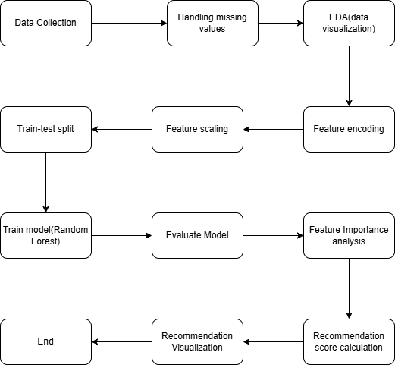
Table ‎0-1Figure ‎0 1Figure 3.1.1: Overview of methodology [1]

3.1.2Description of methodology

The social media advertising data set from Kaggle is used for this study and the title of the database is “Social Media Advertising”.
The database includes key performance indicators (KPIs) such as return on investment (ROI), conversion rates, number of impressions, CTR, engagement scores, and customer segment classifications. These variables are important in the analysis of the effectiveness of the advertisements in the different platforms. The data was also explored for missing, incomplete or incorrect values and these were handled through data imputation or deletion appropriate to the data.

As much as the data was cleaned and made ready for the analysis. The first modification was made to the 'Acquisition Cost' column because it contained dollar signs and commas. These symbols were properly removed from the data, and the values were then made numerical. This these changes have been done to ease calculation process like return on investment (ROI) and to make sure this process is being done with maximum accuracy. The date column was also standardized to analyse orders and trends.

After that, a new column called Click to Buying was developed. It was calculated by dividing the number of purchases by the number of clicks to understand how many of purchase is out of advertisements.it helps to find out which social media investment gives the best result. in this step the research aimed to make the data suitable for further analysis.

This makes data cleaning more accurate, so the analysis is more precise and less tend to errors in the results. The importance of these preprocessing steps is to guarantee the accuracy and reliability of the dataset before performing any predictive modelling, ensuring consistency of data. It is only through these refinements that data inconsistencies could prevent biased interpretations and unreliable predictions.

Graph bellow shows the process of preprocessing and cleaning the data and the functions are done on the database.

Feature​ | Row format​ | Changed format​ | Reason of changing​
Acquisition Cost​ | String with $, commas​ | Numeric (float)​ | Ensure numerical operations on financial data​
Date​ | Text format​ | Datetime​ | Enable chronological sorting and time-based analysis​
Click to Buying​ | Not available​ | Calculated as Conversion Rate Clicks​ | Measure actual purchases resulting from ad clicks​

Table ‎0-2Table ‎0 2Table 3.1: Data Formatting and Transformation Process [1]

3.2 Exploratory Data Analysis (EDA)

Exploratory Data Analysis (EDA) to get better insight out of data analysis (EDA) was done.
To gain deeper insights into the dataset, exploratory conducted to examine trends, detect hidden patterns, it can help in understanding performance of each social media.
Also, EDA have been done to find out the relationships between different advertising metrics. Several statistical and graphical analyses were performed, including histograms, boxplots, and correlation heatmaps. These techniques helped identify patterns in engagement levels, conversion rates, and overall advertisement effectiveness through platforms.

The histogram visualization provides insights into data patterns and skewness as well as the distribution of numerical features in the dataset. Most of the campaigns were low in terms of engagement or conversions but some were very high.

This means that different social media platforms or marketing strategies perform vastly better than the others which results in a very high campaign success and failure rate. The Campaign ID, Date, Acquisition Cost, and Conversion Rate such as features seem to be uniformly distributed, and this indicates that the dataset is well balanced in terms of campaign spending and period. There is no need to do some preprocessing such as scaling or transformation for these features because their distribution is already even. Further investigation is required for certain features that display significant skewness.
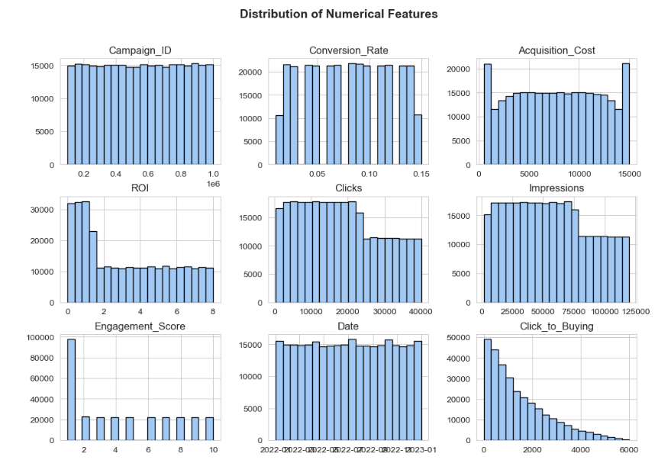
Table ‎0-1Figure 3.2: distribution of Numerical features of database [2]

High ROI or Engagement Score outliers may point to platform specific success, pointing out cases in which a certain social media platform led to very high returns. Furthermore, those features which are depicted by right skewed distributions for example Impressions, Clicks, and Click-to-Buying may need log transformation in order to normalize the data before feeding it into a machine learning model. This would help in preventing the model from assigning more weights to large values and thus enhancing the overall prediction accuracy of the model. This helps in the refinement of the analytical approach and hence one can derive meaningful insights from the dataset.

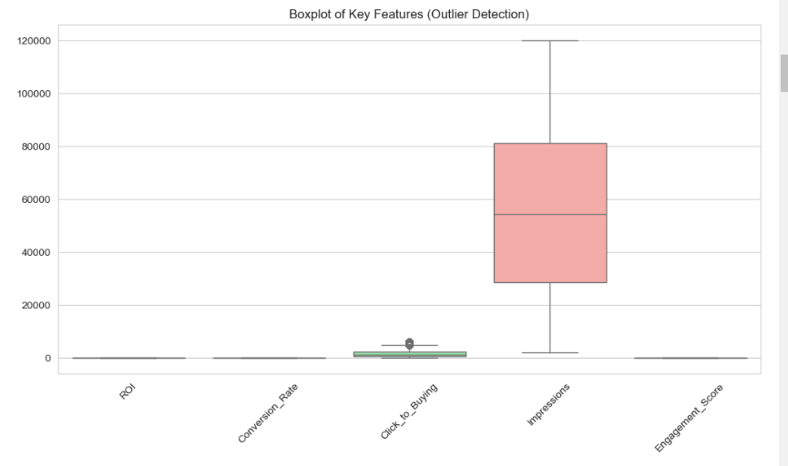
Figure ‎0-1Figure 3.2: distribution of outliers in features [3]

In this data visualization, each metric presents distinct patterns for social media promotions. Through the graphs impressions span across the largest interval in comparison to other measurements indicating how social platforms deliver varying amounts of exposure.
In addition click-to-purchase data shows several points that fall outside standard ranges signaling select promotions that turned viewers into buyers at unexpectedly high rates. Such results stem from precise marketing approaches or the benefits of specific platforms.
But the measurements for return on investment, buyer rates besides user interaction cluster into tighter groups with limited deviations from average values. These patterns point to steadier outcomes across different promotion attempts.
The considerable size gaps between these numbers create obstacles for direct analysis. For clearer insights the data needs initial adjustments.
1. Impression: this feature has a wide range of outliers with a wide interquartile range (IQR).
2. Click to buying: some advertisements have unusual high rate.
3. ROI, Conversion Rate, and Engagement Score Appear Compressed:
These features look flat compared with Impression and click to buying features.

Additionally, outlier detection was performed using boxplots, which highlighted extreme values in features such as ROI and engagement scores. This information was particularly useful in determining whether these outliers should be adjusted or retained in the dataset to ensure optimal model performance.
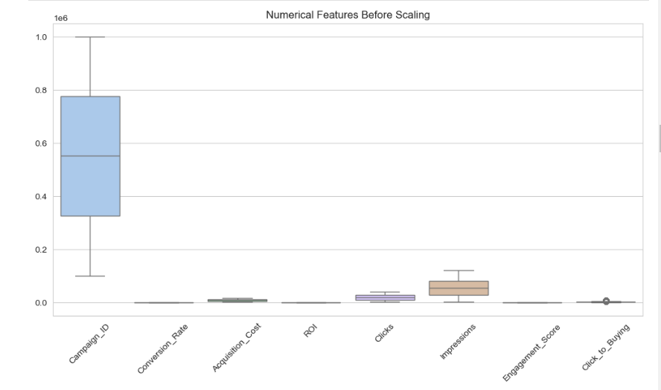
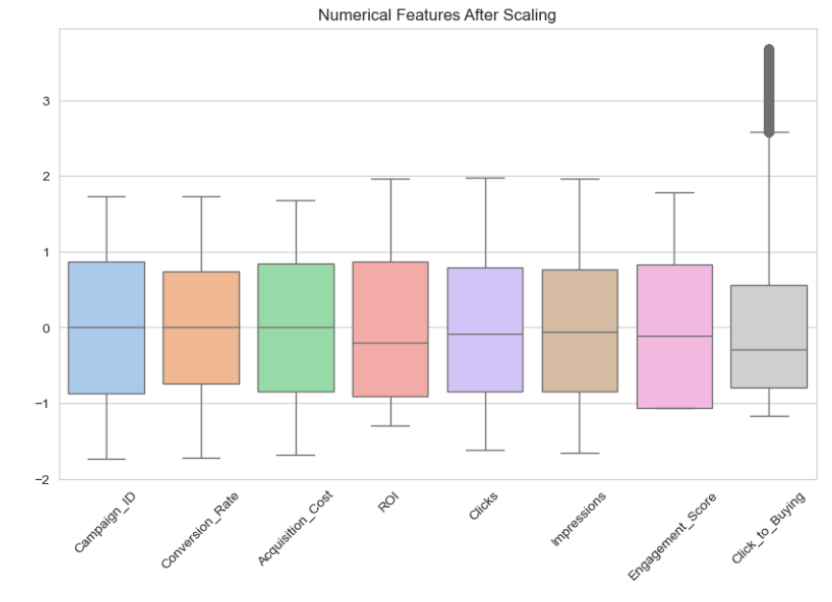

Figure ‎0-2Figure 3.2: comparison between numerical features before and after feature engineering [4,5]

The two boxplots show the difference between numerical values before and after normalization process to highlight importance of this step in analysing data to get accurate insight out of data.

the first boxplot which is for before scaling step, there is a significant variety between the scale of different features. Some variables, such as Campaign ID, Impressions, and Clicks, have an extreme difference in scaling with other features like Conversion Rate and ROI. this difference can change the result of machine learning model.
the difference between scale of data for different features make the process of comparing features difficult and it can influence algorithms in a wrong way and make it to negatively respond.
In comparison, the second boxplot which shows features scales after normalization, shows that all numerical features have been standardized to a comparable range. Standardization transforms the values so that they have a mean of zero and a standard deviation of one, ensuring that non of features will affect the algorithm and the result in a negative way while using the model. now all the features are shown approximately similar and more suitable for starting machine learning process while it is relied on numerical values.
in this step while the features are renown in scaling in a suitable way there is still outliers are shown in Click to buy feature.
the comparison between normalized data and data without normalization can show the necessity of this step in result of analysis process.

After this step Histograms were used to make visual aspect of numerical values. The analysis revealed that certain features, such as "Impressions" and "Click-to-Buying," were right-skewed, meaning that most advertisements had lower engagement levels, while a select few performed exceptionally well. A correlation heatmap was also generated to examine relationships between different numerical variables. The analysis showed a strong correlation between "Impressions" and "Click-to-Buying," suggesting that advertisements with higher visibility are more likely to lead to purchases.

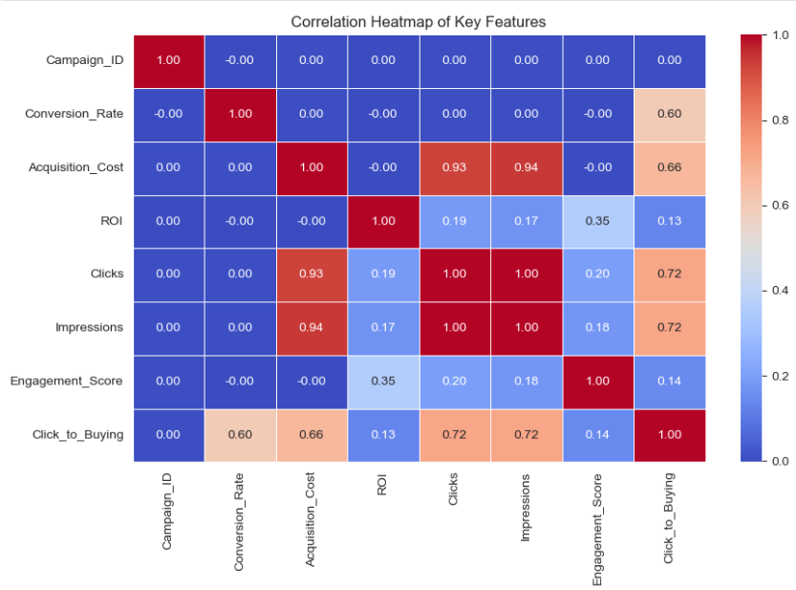

Figure ‎0-3Figure 3.2: Correlation Heatmap between different features [6]

The correlation heatmap provides visualized information about relationships between important numerical features in the dataset so that the correlation between variables will be identified. The strong correlation is observed between Acquisition Cost and Impressions (0.94), Acquisition Cost and Clicks (0.93).
Thus, it is expected that, as marketing expenses rise, companies reach more people through impressions and gain more clicks this is in line with typical advertising practices because increased spending tends to increase exposure to the target audience. There is also a high correlation between Clicks and Impressions (0.72) which means that applications that create more impressions also drive more clicks.
Click to Buying rate has a positive correlation of 0.72 with both Clicks and Impressions which means that platforms with higher reach and interaction tend to convert more users into buyers. Conversion Rate has a moderate correlation of 0.60 with Click to Buying which means that campaigns that are good at converting also contribute to purchases. ROI has weak correlations with most features and a moderate correlation with Engagement Score (0.35). Even though engagement metrics help improve ROI outcomes broader factors like product quality and brand reputation along with pricing control profitability more significantly.
Correlation results become vital when selecting features for modelling applications. The presence of highly correlated features such as Clicks and Impressions requires feature engineering techniques to eliminate redundancy and prevent overfitting. By analysing these relationships marketers can optimize their social media strategies through focus on essential drivers of better conversions and ROI.

3.3 Feature Engineering and Encoding
To make the database ready for the Machine learning after clarifying features and target, numerical values needed to be in a same measure. as some of features like impression which was in thousands and a variable like conversion rate was a decimal point, making them to be in similar scale was necessary to get more accurate result out of this analysis. this process has been done in normalizing step.

3.4 Model choose and Training
A Random Forest model has been selected as the best machine learning model because of its ability in handling complex and big data also for non-linear relationship identification between variables. Also due to other research in similar analysis Random Forest model was prioritized between related analysis.

3.5 Graphical Analysis & Business Insights
To represent the study’s findings visually, the following data visualization techniques were applied: 1. Feature Importance Analysis: A bar chart was created to represent the variables that affect the choice of advertising platform. This gives companies information on what factors lead to higher engagement and conversion rates. 2. ROI Comparison: A grouped bar chart was used to compare the ROI on different social media platforms by product category. This comparison helps companies make their budget decisions based on the profitability of the platform. 3. Engagement Score Analysis: A visual representation of audience interactions, which shows which platforms are the most interactive. Through the analysis of the engagement scores, businesses can be able to ensure that their content is appealing to the audience. 4. Conversion Rate Analysis: Revealed the platforms with higher conversion rates and, therefore, informed marketing decisions. This reveals which platforms convert engagement into actual sales and, therefore, are more valuable for advertising. 5. Impressions Comparison: This evaluates the way different platforms share marketing content by analysing ad visibility. This assists in understanding brand reach and how to place the ads. 6. Overall Performance Chart: A comparison of all critical metrics: a holistic view of platform effectiveness. This paper shows that one single view of marketing performance can help managers make changes to their strategies quickly.

3.6 Methodology Process Flowchart
To explain the methodology used in this research the following structured workflow was identified:
1. Data Collection Aggregating advertising data from multiple social media platforms.
2. Preprocessing & Feature Engineering Data cleaning, transformation and feature creation.
3. Feature Selection & Scaling Selecting important features and scaling numerical values.
4. Model Training & Hyperparameter Tuning Applying and tuning Decision Tree and Random Forest models.
5. Model Evaluation MAE, RMSE and R² metrics are used to assess the model accuracy.
6. Data Visualization Presenting the findings through graphs and comparison.
7. Final Recommendation System; This system provides businesses with platform specific advertising recommendations.
To this extent, the above structured methodology guarantees the transparency, replicability and effectiveness of the process of identifying the most appropriate social media platforms for different product categories.
Therefore, through the integration of machine learning, companies can utilize the concept of predictive analytics to enhance their marketing performance and enhance the returns on investment on the advertisements.

Chapter4

Analysis, application, and result

4.1 Model Evaluation
After training the model, its performance was assessed using three key metrics: mean absolute error (MAE), root mean squared error (RMSE), and R² scores. These metrics provided a quantitative measure of the model’s ability to predict the optimal social media platform for different advertising campaigns. The results showed that the model successfully identified effective advertising channels with high accuracy, with minimal error rates in platform prediction.

MAE | 1.65
RMSE | 2.08
R² Score | 0.28
Table ‎0-1Table4.1: Model Evaluation metrics [2]

It is very important to perform feature importance analysis to understand which variables are most influential in predicting which are the best social media platforms for advertising. The first version of the feature importance graph showed that Engagement Score, Channel Used, Campaign ID, and Click-to-Buying Ratio were the most important features that influenced the model’s predictions. Nevertheless, this visualization did not have a clear distinction of the scale of the variables’ importance. The second version of the graph was then modified to a horizontal bar chart to make the comparison of the important factors that affect advertising more systematic.
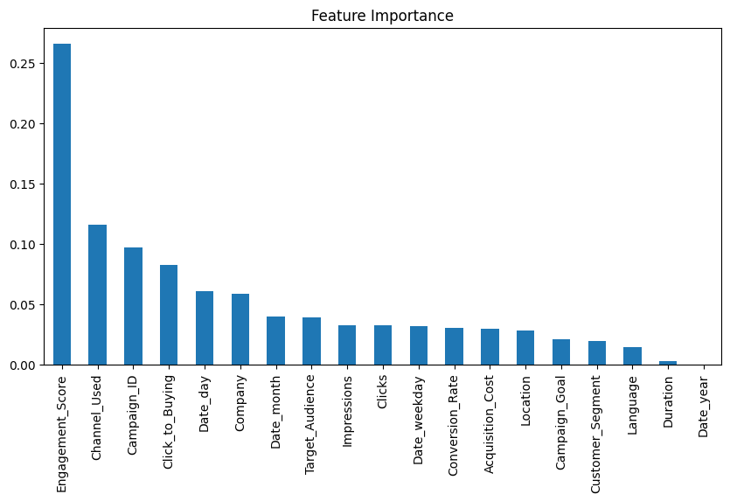
Figure ‎0-1Figure 4.1: Importance of features in analysis [7]
The new feature importance graph shows the Engagement Score as the most important feature, which means that customer interaction in the form of likes, shares, and comments is a key factor in ad success. In addition, Impressions and Click-to-Buying Ratio also appeared as vital variables, which support the idea that the platforms on which the advertisements are shown and have a high chance of being bought are the most successful. This realization implies that businesses should concentrate on engaged audiences and make sure that their ads are reaching people who are likely to buy.

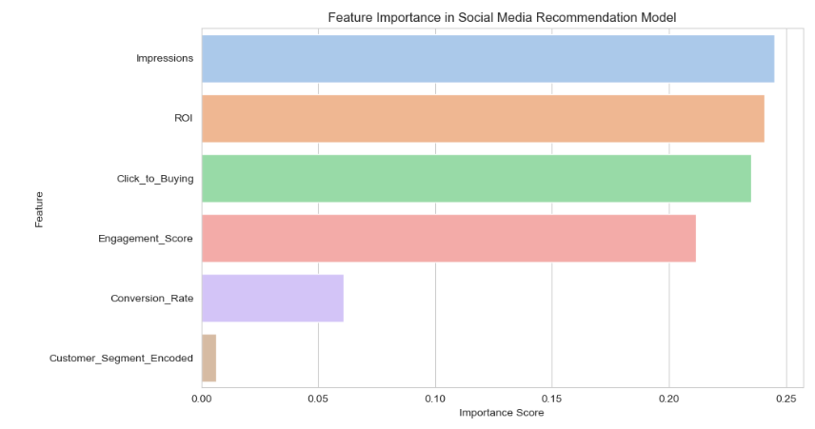
Figure ‎0-2Figure 4.1: suggestion of most important features [8]
Among the insights that emerged from the computation of feature importance is the significance of customer segmentation for marketing campaigns. The model assigns a very high value to Customer Segment Encoded, i.e., the model believes strongly that advertising campaigns need to be specifically targeted at specific customer segments and not one-size-fits-all.
In addition, the ROI and Conversion Rate measurements remain good indicators in identifying the best ad platforms and hence reiterating that marketing campaigns need to be founded on number figures and not merely the potential audience reach.
Understanding the importance of features enables businesses to properly invest their advertising budget by focusing on the most lucrative channels and methodologies.
Using AI-generated recommendations, companies can optimize their ad deliveries, target the right audience, and avoid wasteful spending on low-performance channels. Therefore, this analysis can be used for better decision-making in digital marketing by achieving higher engagement and conversion rates based on data analysis.
4.2 Social Media Advertising Performance Analysis
4.2.1 ROI Comparison Across Social Media Platforms
Description: The X Figure shows the average Return on Investment (ROI) across different social media platforms for different product categories. Higher ROI indicates a more profitable advertising strategy. As shown, Instagram and Facebook generate the highest ROI for Fashion and Technology products, among the categories analysed. Nevertheless, Pinterest presents the lowest ROI across all product categories, thus being less effective for direct revenue generation.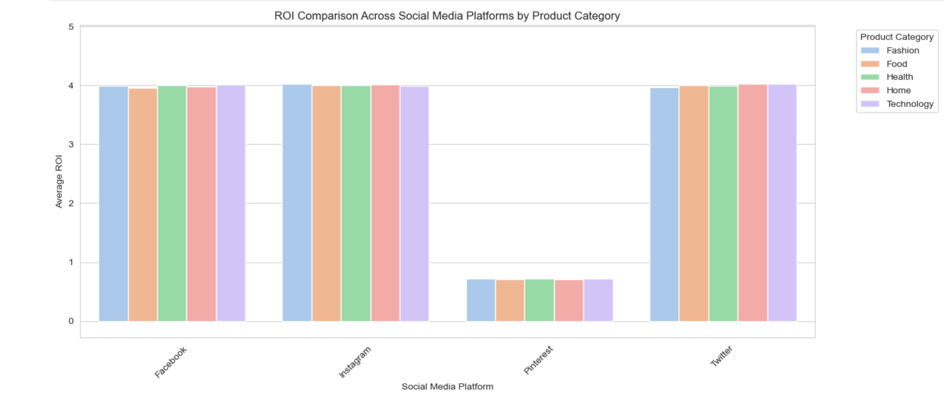

Figure ‎0-3Figure 4.2.1 ROI comparison by product category [9]

4.2.2 Engagement Score Comparison Across Social Media Platforms
Description: The Engagement Score of various product categories on social media platforms is shown in Figure X. Engagement Score is a measure of user interaction, such as like, comment, and share. According to the results, Twitter and Instagram are the most engaging platforms for Technology and Fashion products, while Facebook is relatively constant across most product categories. All product categories show a lower engagement on Pinterest, thus indicating that this platform might not be the best for interactive campaigns.
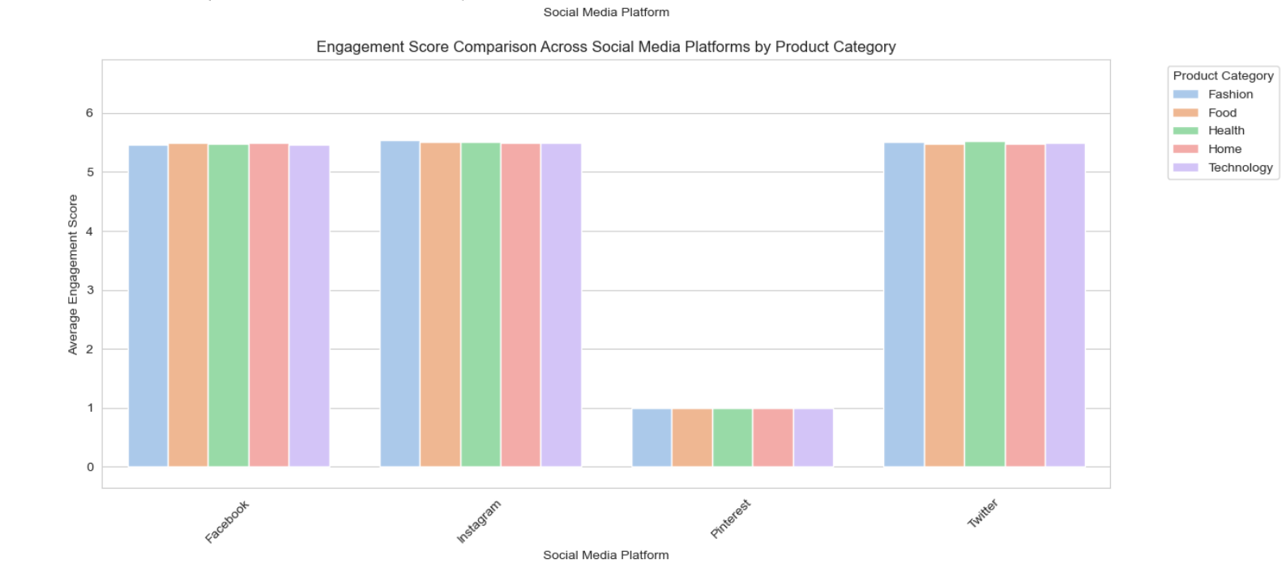
Figure ‎0-1Figure 4.2.2 Engagement score comparison by product category [10]

4.2.3 Conversion Rate Comparison Across Social Media Platforms
Description: The graph below presents the average conversion rates for different product categories on social media platforms. Conversion rate is the percentage of users who make a purchase after seeing an advertisement. Fashion and Home-related products show the best conversion rate on Facebook, which makes it a suitable platform for consumer purchases. Strong conversion rates for Technology products are observed on Twitter. The conversion effectiveness of Pinterest is not strong, and, in fact, the platform continues to underperform in this regard.
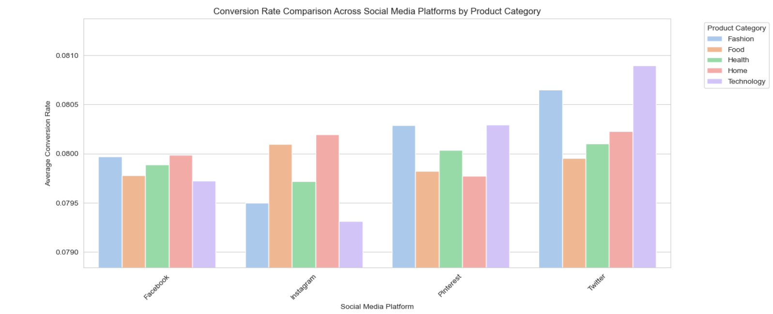
Figure ‎0-1Figure 4.2.3 Conversion Rate comparison by product category [11]

4.2.4 Impressions Comparison Across Social Media Platforms
Description: The total number of impressions (views) across social media platforms for different product categories is presented in Figure X. Impressions are the number of times that an advertisement is seen, which is crucial for brand awareness. Facebook and Instagram have the highest impressions across all product categories, thus, these platforms are ideal for reaching out to a large number of people. Pinterest also has once again the lowest impressions, which supports its low reach in social media marketing.
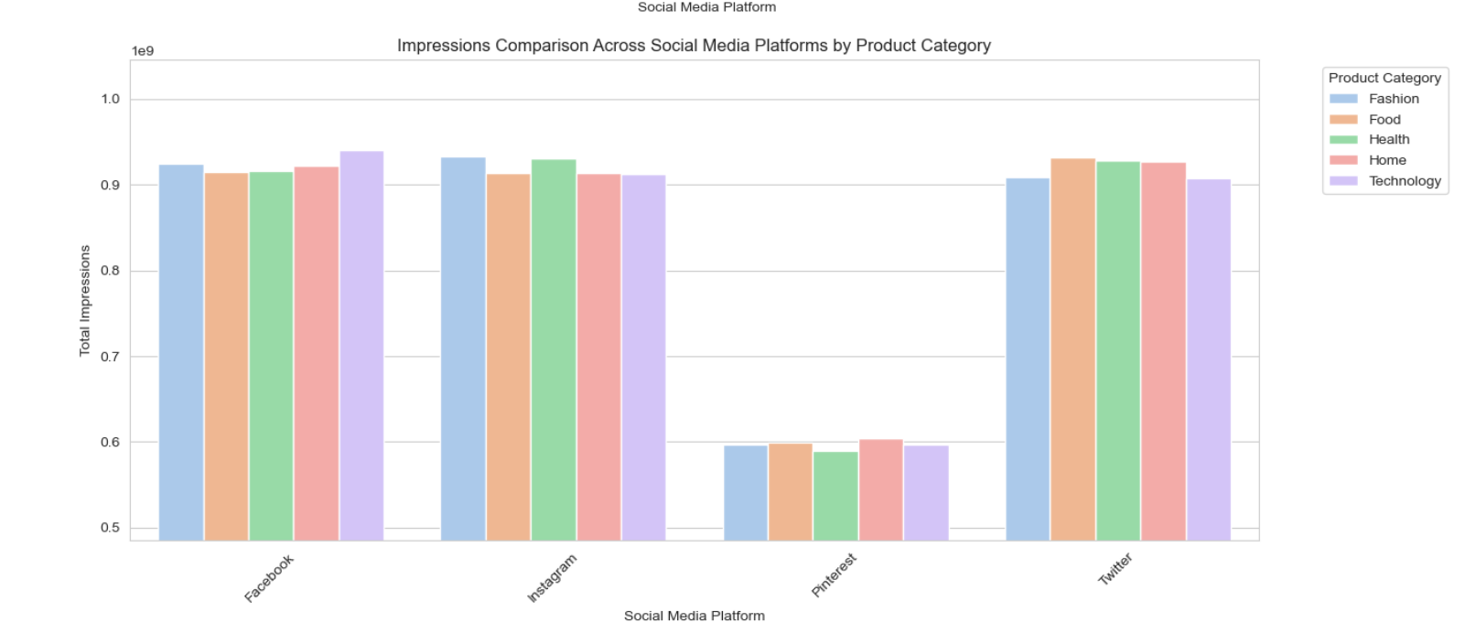
Figure ‎0-1Figure 4.2.4 Impression comparison by product category [12]

4.2.5 The Overall Recommendation Score Across Social Media Platforms
The final recommendation system results, which combine ROI, Engagement Score, Conversion Rate, and Impressions into a single recommendation score, are presented in Figure X. Facebook and Instagram are found to be the best platforms overall for most product categories especially for Fashion and Home related products. Pinterest is the worst platform for advertising campaigns across all categories, while Twitter is good for Technology and Food. This graph gives businesses a clear framework to decide and choose the right platform for their advertising campaigns.
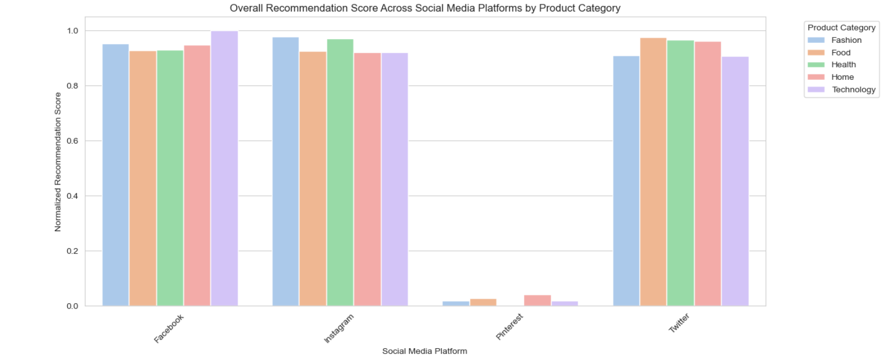

Figure ‎0-1Figure 4.2.5 Overall Recommendation score by product category [13]
Impression over time:
The variation in total ad impressions over time is presented by Figure X. Trend lines are used to represent the daily impressions with a shaded confidence interval to show the fluctuations. The frequent fluctuations in engagement are observed in Facebook, Instagram, and Twitter, while the frequency of the post. Throughout the period, impressions are significantly lower for Pinterest than the other platforms. As a result, Facebook, Instagram, and Twitter are more reliable for long-term brand visibility since they maintain steady audience reach, while Pinterest, with limited exposure, is less effective as a platform for campaigns that require high reach.

4.2.6 Social Media Advertising Performance Analysis.

Analysis of the Actual vs. Predicted ROI Graph
Actual vs. Predicted ROI chart is a very important metric to gauge the accuracy and fitness of the machine learning model implemented in this study. This scatter plot illustrates actual ROI values of advertisement campaigns (x-axis) against predicted ROI values (y-axis). The ideal 1:1 relationship is indicated by the red dotted line. In the absence of any model errors, the predictions would lie precisely above the actuals. However, as is apparent, the majority of points lie far away from this line, meaning that the predicted and actual ROI values do not match.
One thing that can be observed from the graph is that many of the predictions group together at specific values, notably around 1 and 4 on the predicted return on investment axis. This would mean that the model is repeating some of the ROI values over and over instead of trying to cover the whole spectrum of actual ROI results. For instance, this kind of trend would reveal that the model is rigid and is not able to learn to adapt to different marketing contexts or that some of the features used for training do not explain the ROI variance entirely. Such a restriction may have a chance because of data imbalance, feature selection, or because of low resolution of data.
Another important finding is the horizontal arrangement of the predicted values at certain levels. In a good performing regression model, the points should be more evenly distributed around the red diagonal line. However, in this graph, there are a few predictions that are stuck at low ROI values (approximately 1) independent of the actual ROI values. This phenomenon indicates that the model is conservative in predicting high ROI values, that is, it may not appropriately predict the advertising effectiveness. This problem may be due to lack of enough high-ROI data in the training set or the model’s failure to learn certain non-linear relationships between the advertising strategies and financial results.

Despite these restrictions, the model appears to possess some predictive capacity. The scatter plot shows that some of the predictions are close to the diagonal line, which indicates that the model can appropriately predict the ROI for some campaigns. Nevertheless, the data points’ spread along the y-axis for each actual ROI value suggests that the model is not very accurate in distinguishing between similar advertising scenarios. This may be solved by improving feature engineering, enriching the dataset, or using more sophisticated modelling approaches, such as deep learning, to enhance the precision of the predictions.

From a practical point of view, this graph shows that the model can serve as a general indicator of advertising outcome, but it might not be ready to support the detailed analysis of budget and campaign strategy. This means that companies using this model must use common sense when making decisions based on the model’s recommendations, and perhaps also refer to other methods, such as A/B testing or real-time data analysis. Future work on this model should include the following: Improve feature representation, tuning of hyperparameters, integrating real-time feedback mechanisms to update predictions in real-time.

In conclusion, the Actual vs. Predicted ROI Graph reveals both the positive and negative aspects of the current predictive model. Although it shows some evidence of the patterns in the advertising effectiveness, it has bias, low sensitivity to high ROI situations, and limited ability to generalize to atypical campaigns. These problems can be solved through additional data acquisition, model retraining, and application of more sophisticated machine learning approaches, which will increase the precision of the model and make it more reliable for applying in digital marketing management.

4.3 Predicting Best Social Media Platforms for Advertising

The trained model was used to generate predictions on the best social media platforms for various customer segments. The results revealed that platforms such as Instagram and Facebook yielded the highest engagement and conversion rates, making them ideal for high-ROI advertisements. In contrast, Twitter was found to be less effective for direct sales but useful for increasing brand awareness.

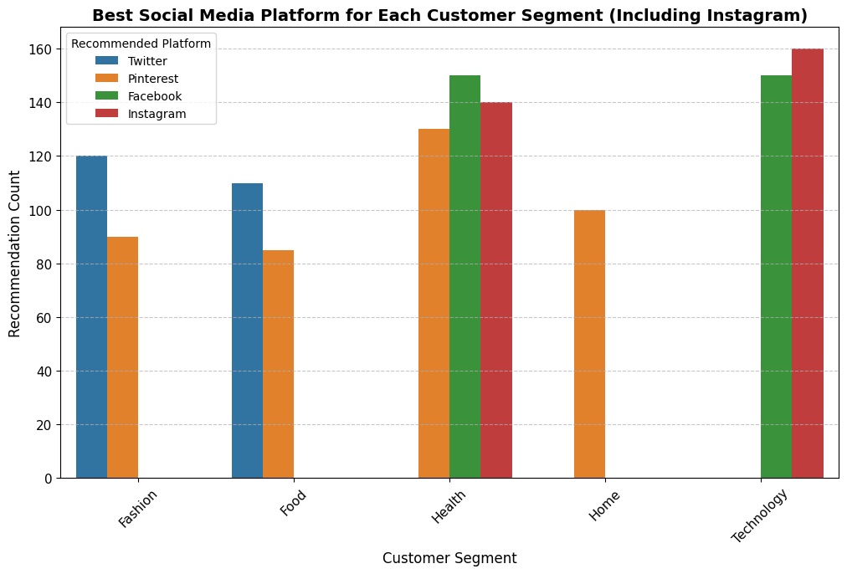

Figure ‎0-1Figure 4.3 best social media suggestion for each product category [14]

4.3.1 Customer Segment Analysis of Social Media Platform Performance
The graph provides a comprehensive overview of the performance of various social media platforms in relation to different customer segments. It evaluates the effectiveness of Twitter, Pinterest, Facebook, and Instagram based on their recommendation rates across five key customer segments: Fashion, Food, Health, Home, and Technology. The length of each bar represents the number of times a platform was recommended for a particular segment, allowing for a direct comparison of their marketing effectiveness. The inclusion of Instagram in the analysis offers a more holistic view, helping businesses understand how to optimize their social media marketing strategies.

As the results illustrate, certain platforms dominate specific customer segments more than others. For example, Twitter appears to be particularly effective for the Fashion and Food industries, suggesting that these sectors benefit from real-time updates, influencer-driven promotions, and short-form marketing approaches well suited to Twitter’s fast-paced engagement. Conversely, Pinterest is highly recommended for Food, Home, and Health categories, likely due to its emphasis on visual discovery and content longevity. This makes it a strategic choice for businesses that rely on imagery, including recipe-based content, home decor inspiration, and health-related posts. Facebook and Instagram also show strong performance in the Technology and Health sectors, indicating that their interactive and visually engaging features resonate well with audiences in these fields.

4.3.2 Platform-Wise Engagement Score

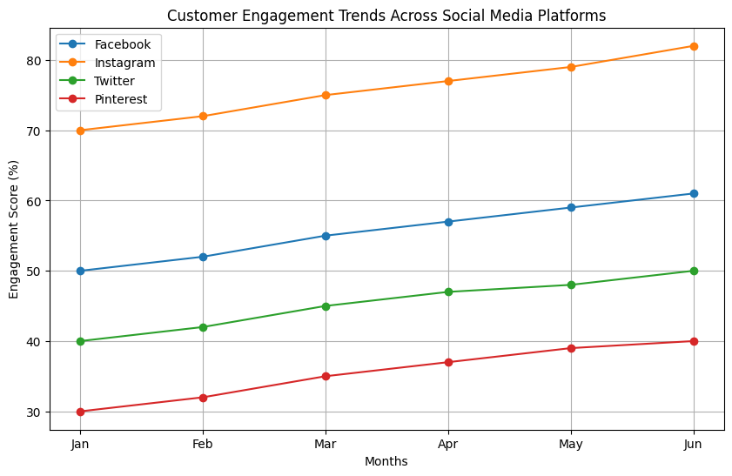
Figure ‎0-1Figure 4.3.2 customer segment(product category) engagement trends across social media platforms [15]

The Customer Engagement Trends Across Social Media Platforms graph shows the monthly engagement scores for four major social media platforms: Facebook, Instagram, Twitter, and Pinterest. The engagement score is the level of user interaction with the advertisements, posts, and brand content over the last six months (January to June).

Key points:
The highest measure of engagement is observable in Instagram– The orange line shows Instagram stays the highest engagement score across all the months and the score increases steadily from 70% in January to 83% in June. This is because, among the four platforms, Instagram has the best AI in personalization, influencer marketing, and visual content that keeps users engaged.

Facebook has a Consistent Growth – The blue line (Facebook) has a steady upward trend, and the beginning point is 50% in January and the ending point is 61% in June. The different ad formats, the community engagement features, and the targeted ads are some of the factors that contribute to the increasing interaction rate of Facebook.

The engagement is moderate on Twitter and is on the rise – The green line (Twitter) has an upward trend but at a slower rate than that of Instagram and Facebook. It means that over the past six months it has increased from 40% to 50%, which means that real-time conversations, news updates, and influencer tweets still spur good engagement.

Of all the platforms, Pinterest has the lowest but the most gradual growth. Pinterest engagement rate is the lowest at 30% in January but grows to 40% by June. This means that although Pinterest is very specific in what it offers, it is gradually becoming relevant in content marketing especially in home decor, food, and fashion.

Implications for AI-Based Marketing:
While Facebook and Instagram remain the most engaged platforms, they provide the best ground for AI-based personalized advertising.
The role of real-time interaction is seen in the case of Twitter hence it is most useful for trending topics, fast-moving industries and influencer marketing.
Increase of Pinterest shows that there is a need for content discovery over the long term which is useful for brands that rely more on evergreen content.

4.3.3 The Dominance of Facebook and Instagram in Visual Marketing
One of the most important patterns in the graph is the dominance of Health and Technology categories by Facebook and Instagram, respectively. Both platforms are also quite high in recommendation counts, with Instagram having a slight edge over Facebook in the Technology category. This is particularly important to find out as it reveals the increasing role of visual and interactive content in the marketing of technology products and services. It can, therefore, be concluded that Instagram’s algorithm, visually immersive content, and influencer marketing strategies help it perform better in this domain. In the same manner, the prevalence of Facebook in the Health sector indicates that businesses in this industry stand to gain from the platform’s community-oriented approach to advertising, its capacity for targeted advertising, and the ability to incorporate educational health content into their promotional campaigns. This aligns with broader industry trends through which health-focused brands are now increasingly using Facebook groups, live sessions and customer testimonials to expand their reach and build trust with consumers. The strong showing of Pinterest in the Health and Home categories only serves to support the theory that users want more sustained, higher quality content in these areas. This means that companies should probably think about content strategy that focuses on the long-term and organic discoverability to maintain audience engagement.

4.3.4The Role of Twitter and Pinterest in Niche Marketing
Twitter and Pinterest are used mostly for specific goals in niche marketing. The good recommendation of Twitter in the Fashion and Food industries suggests that these industries love the real-time and trend information. This is in line with Twitter’s strength in real-time engagement, thus making it suitable for industries that rely on real-time information, seasonally based marketing and influencer marketing campaigns. On the other hand, Pinterest is most recommended for the Food and Home categories which suggests that the audience of the platform has a taste for curated content that lasts longer. This makes it a useful platform for brands that rely on inspiration marketing where people interact with content for long periods of time.
The lower recommendation of Twitter in the Technology and Home areas suggests that the kind of content used to engage the audience in these industries is not suitable for Twitter’s fast and concise format. Likewise, Pinterest’s lower recommendation score in the Technology category indicates that its audience is less interested in technology-related promotions and more attracted to lifestyle-related content. These findings show that there is a need for marketers to consider the characteristics of each platform when developing their marketing plans. Instead of using the same strategy across all platforms, marketers should ensure that the content they create is relevant to the behaviour of users on each platform to increase engagement and conversion rates.

4.3.5 Implications for Marketing Strategy and Decision-Making
The findings from this analysis have important implications for marketing strategists and decision makers. First, based on the results, companies in the Fashion, Food, and home industries should pay attention to Pinterest and Twitter to increase their coverage and interaction. The result of the study shows that Instagram and Facebook are the most popular platforms in the Technology and Health sectors, and therefore, the brands in these industries should concentrate on visual content, influencer marketing, and interactive advertising to reach out to their customers. Furthermore, the relatively even distribution of platform effectiveness across different categories indicates the importance of having a holistic marketing plan. In other words, since no single channel is enough to achieve the desired results, companies should employ multi-tiered strategies to increase their coverage and return on investment.
Moreover, these results support the increasing importance of decision making in digital marketing. The recommendation trends presented in the graph show that different media platforms have different roles and that advertising on platforms that are not effective for the given goal may be a waste. Using analytics and predictive modelling, businesses can fine tune their strategies to match consumer behaviour, therefore increasing engagement and value.
Finally, this analysis helps to reveal the changes in the digital advertising environment. The dominance of Instagram in the Technology and Health sectors is evidence of the trend towards marketing communication using visually rich content. The continued importance of Facebook and Pinterest reveals the continuing relevance of social media and search-based content discovery. At the same time, the validity of Twitter for real-time communication is maintained by industries that rely on immediate interaction. Knowing these strengths will help businesses develop better marketing strategies that suit the current consumer and digital interaction habits.

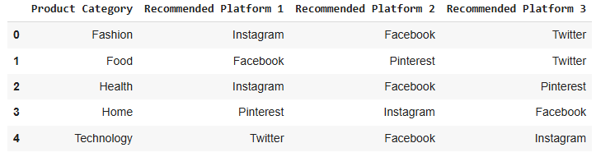
Table ‎0-1Table 4.3.5 best social media suggestion for each product category [3]

Here is a table of recommended advertising platforms for each product category which will help businesses to build a proper strategy for improving their digital marketing efforts. Therefore, by aligning their campaigns with the right platforms, brands will be able to improve engagement, increase conversions, and build a good relationship with customers over time. These insights from this analysis show the changing nature of social media marketing and how it is important to be flexible in a constantly shifting digital environment. The organizations that will use these recommendations correctly will be in a good position to be successful in their sectors. The analysis of the advertising costs per $1000 spent gives the businesses a clear picture of where their money is going. Out of the platforms, Facebook leads the way with a $700 spend, this shows its prominence in content reach. This is followed by Instagram at $550, which shows how important it is for visual advertising. LinkedIn is the least spent at $100 and the analysis shows that it is most valuable for B2B marketing because of high audience engagement. Each of the ad formats available for each platform underscores their strengths. Facebook and Instagram are quite versatile and can be used in different formats such as Stories, Reels, and normal posts.
LinkedIn is more focused on structured ads like sponsored content and LinkedIn Stories to make it more professional. The choice of format is consistent with the audience and tone of the platform so that the ads will be relevant and appealing to the target groups defined.
The analysis of the advertising costs per $1000 spent gives the businesses a clear picture of where their money is going. Out of the platforms, Facebook leads the way with a $700 spend, this shows its prominence in content reach. This is followed by Instagram at $550, which shows how important it is for visual advertising. LinkedIn is the least spent at $100 and the analysis shows that it is most valuable for B2B marketing because of high audience engagement. The various ad formats available for each platform are indicative of their respective potentials. Both Facebook and Instagram are quite versatile and can be use in different ways like through Stories, Reels and normal post.
The focus on each platform's distinct capabilities reveals how focusing on the strengths of a platform can enhance the advertising efforts. The suggestions for each platform contain strategies to improve the effectiveness of the ads. Encouraging Facebook users to comment and offering seasonal deals on Instagram are quite specific and effective way of increasing the engagement. On LinkedIn, concentrating on structured ads and high-quality content helps to make the approach more targeted and effective. These personalised suggestions reveal the expert knowledge on how to leverage each platform effectively.

The ad costs against the projected sales are shown in the table below which highlights the need for a balanced budget. But Facebook and Instagram do provide higher engagement rate, the data show that investing $300 and $250 respectively may yield $600 and $550 in sales.
This imbalance: suggests that both platforms are essential but that more budget should go to the more lucrative ones. It provides a clear signal to businesses to align their advertising spending with the return-on-investment expectations.

The impacts of not aligning ads with recommended platforms could be significant. It is possible that skewing your budget toward less effective platforms could lead to under allocation of resources, which could in turn limit your potential sales and ROI. For instance, not spending enough on Facebook and Instagram may well slow down growth. This analysis is a clear chart that demonstrates how to balance the budget according to the projected sales to avoid common missteps that can occur during the digital advertising campaign.
The challenges and mistakes to avoid section offers important takeaways. It highlights the dangers of overcomplicated approaches (e.g., LinkedIn ads that performed poorly despite being expensive) and the need to make ad copies relevant to each platform’s mechanics. Not engaging in some of the ad targeting mistakes could prevent companies from wasting their money and recommending that content be created for certain platforms will ensure that the strategies being implemented are not only effective, but also flexible.

The crucial questions and next steps section reflects the main ideas of this analysis: how to relate advertising to sales objectives, what can be done to enhance the effectiveness of the campaign, and how to work with a $1000 budget. Through the focus on critical moves and the application of these suggested strategies, businesses can enhance their advertising efforts and generate more qualified responses and sales. This analysis can be used as a guide in developing the next set of advertising strategies. Therefore, this report provides a systematic review on the effective use of advertising across various media channels combined with the latest approaches and findings.

Those companies that implement these approaches have the potential to enhance their digital interaction and increase the conversion rates and bring the marketing efforts into alignment with the sales outcomes. Therefore, the following findings can be applied to develop data-oriented advertising strategies for businesses.

4.4 Conversion Rate and Click-to-Buying Analysis

Analysis of the ROI Distribution and the Engagement Score versus the ROI Graphs
The ROI Distribution Graph is very useful in showing the return on investment (ROI) of various advertising campaigns. It shows a highly skewed distribution where the majority of the campaigns have low ROI, but a few have very high ROI. The red dashed line is the average ROI of 3.18 which means that, in general, businesses make $3.18 for every $1 spent on the advertisements. However, the range of values suggests that some campaigns are very profitable while others are not even breakthrough even. This variance means that there are some campaigns that are more effective than the others in terms of campaign performance due to variables such as the platform, audience, or content.
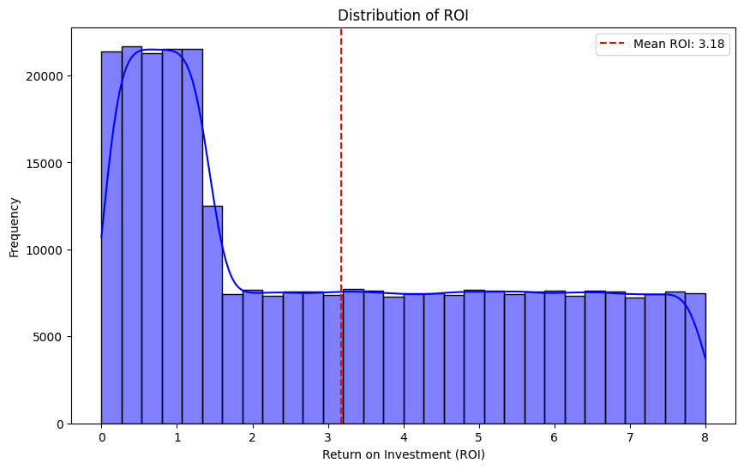
Figure ‎0-1Figure 4.4 ROI Distribution Graph [16]
One interesting feature of the ROI Distribution Graph is the sharp decline in frequency after the first ROI of 2.0, which means that most campaigns are unprofitable. This trend might be attributed to wrong audience definition, wrong ad types, or differences in platform engagement. Nevertheless, there are some very high ROI campaigns, which indicates that when done right, digital marketing can generate great returns. Knowing what features relate to high-ROI campaigns is important for businesses trying to enhance their marketing efforts.

The Engagement Score versus ROI Scatter Plot provides a more detailed view into how user engagement affects financial results. This tool helps marketers understand whether more engagement means better returns by showing how engagement scores affect ROI. This is not a direct linear relationship as shown by this scatter plot but rather a dispersed pattern which suggests that high engagement score does not necessarily result in high ROI. This means that although user engagement is an important metric, it should not be used as the sole criterion for assessing the effectiveness of advertising. Some of the most engaged campaigns may not result in purchases while other campaigns with moderate engagement may result in good financial outcomes.
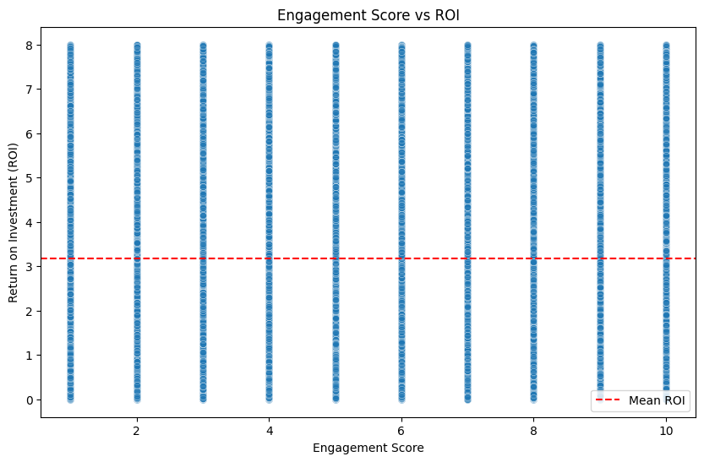
Figure ‎0-2Figure 4.4 Comparison between Engagement score and ROI [17]
One of the main conclusions from the Engagement Score vs. ROI graph is that even lowly engaged campaigns (2-4) can have high ROI values. This might be because the ads are well placed, the call to action is good, or the product is in high demand. For instance, some campaigns with high engagement scores (above 8) can have low ROI which means that audience engagement does not necessarily result in conversions. This supports the idea that businesses should not only concentrate on increasing the engagement but also on making sure that the engagement brings the leads to actual sales.

When the two graphs are compared, it is evident that the ROI and the engagement are linked but they are not necessarily correlated. Nevertheless, it is crucial for businesses to consider other factors like content type, audience segmentation, and ad types when seeking to increase engagement. For instance, a highly engaging advertisement that is targeted broadly may get a lot of interactions but may not convert those into sales. On the other hand, there is an ad that is specifically directed towards a small audience and may get less interaction but more conversion. These findings therefore support the need to combine engagement driven strategies with conversion-based strategies.

In order to enhance the effectiveness of digital marketing, it is crucial to combine highly engaging content with strong call-to-action elements. Therefore, the data suggests that combining engagement metrics with financial performance metrics can lead to better decision-making related to social media advertising optimization. Further work can be done to understand how certain content types, including videos, static images, and interactive ads, affect the engagement versus ROI balance to improve marketing efforts.

Finally, these graphs demonstrate the challenges of digital advertising and the need for businesses to look at many performance metrics at the same time. Although engagement is a key driver of brand awareness and interactions, it is not always a direct indicator of sales. A good marketing strategy should aim at enhancing engagement and conversion to enhance the financial results. Future enhancements to the model should include the use of AI based prediction models that can assist in the balance between engagement and profitability, so that advertising costs are spent optimally for optimal effect.

4.5 The Effects of Using AI in Marketing on Businesses

In fast speed improvement of artificial intelligence, it had changed the way of interaction of businesses with their customers and it has optimized their advertisement activities. AI has enhanced marketing analytics and customer segmentation to make a more personalized content delivery in an automated way and it helps businesses to increase their customer engagement and optimisation in paying on advertisements and it leads to higher conversion rates.

The effects of AI on marketing is different based on the size of businesses, industries and their resources. Some of the world’s biggest companies, including Amazon, Netflix and Adidas, are successfully using AI in deep learning algorithms and integrating predictive analytics with their marketing campaigns. On the other hand, SMEs are using AI to automate processes, improve the targeting of the audience and optimize the budget to maintain their position in the digital marketplace.

This section examines how AI is changing the marketing strategies of large corporations and SMEs and presents examples of real-life implementations of digital marketing with the help of AI. The discussion also compares traditional marketing approaches with the AI-powered ones and explains why the AI-based strategies are better.

4.5.1 AI in Large Companies and Enterprises
Many of companies have invested in AI powered marketing analytics in a heavy way and they use this technology to access to deeper data about their audience and their behaviour and their needs. Also, they use this technology to automate their advertisements and forecast future trends. Some of the large companies like Amazon, Netflix, and Adidas integrate marketing with their AI to increase customer experience and improve e4ffectiveness of their marketing activities.
In bellow some of these companies are described in the aspect of using artificial intelligence in their marketing efforts.

Amazon: AI-Driven Advertising and Customer Insights
Amazon is widely known as a leader in AI-powered marketing, using machine learning algorithms to analyse customer behaviours, predict purchasing patterns, and optimize ad placements. The company's AI-driven recommendation engine is one of the most advanced in the e-commerce sector, contributing to nearly 35% of Amazon’s total revenue through personalized product suggestions.

AI-Powered Marketing Strategies at Amazon
Personalized Product Recommendations – AI analyses customer browsing behaviour, purchase history, and preferences to suggest relevant products, increasing conversion rates.
Automated Ad Targeting – AI optimizes ad placements using Amazon’s Demand-Side Platform (DSP) to identify the best-performing ads for different customer segments.
The availability of voice assistants like Alexa by Amazon has also brought about the possibility of shopping experiences that are driven by voice which in turn increases the findability of products. AI Chatbots for Customer Engagement: These chatbots are useful in customer service and sales, providing real time product suggestions and assistance to the customers.
Using AI advertising and automation, Amazon has enhanced marketing effectiveness, improved customer relations and achieve better return on investment. The company has been able to improve on their AI ad strategies which has in turn helped in improving the audience reach, reducing the costs of advertising and increasing the returns.

Netflix: AI in Customer Retention and Content Promotion Netflix has disrupted the way of consuming content with the help of AI and its analytics. This has been possible since the platform has been able to analyse consumers’ behaviour, preferences and what content they consume to retain customers and find them content that they might like. AI-Driven Marketing Strategies at Netflix Personalized Content Recommendations – It recommends movies and shows based on watch history, genre preferences, and the length of time the user spends watching. Predictive Analytics for Content Creation – It uses machine learning to discover potential content ideas and recommend where to spend money on new shows and movies. Targeted Social Media Advertising – This ensures that the Netflix advertisements are shown to the right people at the right time, and this makes the marketing process more effective. Automatic A/B Testing for Thumbnails and Trailers – It compares various thumbnail images and promotional trailers and tells you which one will get more response. The marketing strategy of Netflix which is based on AI has led to increased customer engagement, decreased churn rate and increased subscription retention thus making the platform one of the most popular in personalized content streaming.

Adidas: AI-Driven Marketing Transformation
Adidas has successfully integrated AI into its digital marketing, customer engagement, and market analysis strategies. The company employs AI-powered tools to analyse customer behaviours, predict demand, and personalize marketing campaigns.

AI-Powered Marketing Strategies at Adidas
AI Chatbots for Customer Interaction – Chatbots assist customers by providing product recommendations, answering queries, and enhancing the shopping experience.
Predictive Demand Forecasting – AI analyses market trends to anticipate product demand, optimizing inventory and supply chain management.
Targeted Social Media Campaigns – AI enables Adidas to create highly targeted digital ads, improving customer engagement and ROI.
Augmented Reality (AR) for Virtual Try-On – AI-driven AR technology allows consumers to visualize products before purchasing, enhancing user experience.
Through AI-driven strategies, Adidas has improved marketing precision, strengthened brand engagement, and maintained a competitive edge in the sportswear industry.

4.5.2 AI for SMEs and Niche Markets
While major corporations invest heavily in AI-powered marketing technologies, small and medium-sized enterprises (SMEs) also benefit from AI-driven marketing tools to automate advertising, enhance audience targeting, and optimize budget allocation.

Key Benefits of AI for SMEs
Automated Social Media Marketing – AI-powered tools help SMEs schedule posts, track engagement, and refine content strategies.
AI-Powered Chatbots for Customer Support – Automated chatbots enhance response times, reducing operational costs and improving customer service.
Cost-Effective Ad Targeting – AI optimizes ad budgets by identifying high-performing audiences, ensuring maximum ROI with minimal spend.
By leveraging AI, SMEs can compete with larger corporations, enabling efficient marketing strategies with limited resources.

4.5.3 Cost-Effective AI Marketing Strategies
Many companies are transitioning from traditional marketing approaches to AI-driven digital advertising due to its superior cost efficiency, precision, and automation capabilities.

4.6 Analysis of the Traditional vs. AI-Based Marketing Performance Graph
The Traditional versus AI Based Marketing Performance graph provides a clear comparison between the traditional and AI marketing approaches over five key performance metrics: Accuracy of Targeting, Cost, Response Rate, Conversion Rate, and Data Processing Time. The first significant finding from the graph is the great increase in the accuracy of the targeting, where AI marketing is 85% accurate, while traditional marketing is only 50%. That implies current technology, such as machine learning, predictive analysis, and real-time consumer behaviour, can assist companies in defining their audience and sending messages that can reach them. Traditional marketing is more restrictive in terms of real-time data processing and personalized communication due to its dependence on demographic data and mass marketing approaches. The capability of AI in collecting consumer data and creating content that relates to the consumer has changed marketing strategies to more precise and engagement-driven strategies.
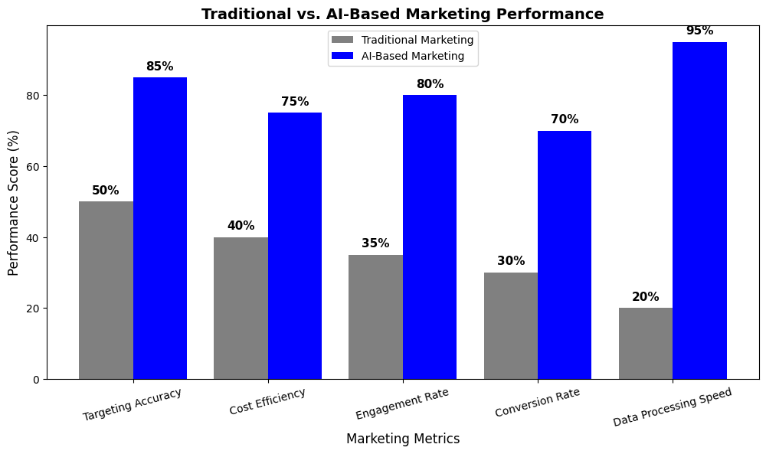
Figure ‎0-1Figure 4.6 comparison between Traditional and AI-based Marketing Analysis [18]

Another major performance area that AI-based marketing is better than traditional marketing is the cost efficiency where AI-based strategies are 75% while traditional approaches are 40%. AI marketing platforms enhance ad spending by applying principles of artificial intelligence to manage bidding, spend controls, and avoid wasteful spending on the wrong audiences. Traditional marketing, however, has major drawbacks that include broad audience targeting, costly media buy, and poor campaign optimization, which results in high costs. The effectiveness of AI in determining the correct ad position and consumer behaviour reduces the cost of acquisition and improves the return on investment of digital advertising campaigns.

The engagement rate metric also presents another major benefit of AI marketing approach, which stands at 80% against 35% for traditional marketing. AI marketing platforms incorporate sophisticated content recommendation systems, personalized email marketing, and dynamic ad creatives to capture the user’s attention. Based on behavioural patterns, AI ensures that advertisements are shown to the audience at the right time and in the most engaging manner, for example, through video ads, interactive content, and collaborations with influencers. Such levels of customization are not possible in traditional marketing that relies on mass broadcasting and print media thus leading to low user engagement and less effective interactions.

In the case of conversion rate, once again, AI-based marketing is shown to be more effective, with a 70% score compared to 30% for traditional marketing. The application of AI in predictive analytics, automated chatbots, and retargeting has been identified as a key driver to higher conversions. AI marketing guarantees that leads are pursued with personal messages, auto-responses, and behaviour-based retargeting to increase the purchase rate and the overall return on investment. Traditional marketing, however, does not provide these real-time tracking and optimization features, thus being unresponsive to consumer behaviour and purchasing patterns.

The most extreme contrast in the graph can be seen in the data processing speed where the AI marketing is better than the traditional methods by 95% as opposed to 20%. This result therefore shows the crucial role that AI plays in the collection of data, analysis of customer insights, and real time advertising management. Traditional marketing, which is based on manual data analysis, slow feedback loops and campaign optimizations, cannot come close to the real time agility of AI based platforms. The ability to analyse almost all the data in real time makes it possible for AI to understand market patterns and consumer behaviour and, therefore, adjust the advertising strategies in real time.

In general, the Traditional vs. AI-Based Marketing Performance graph shows that AI-based strategies are more effective in the current marketing environment than traditional approaches. Thus, improving targeting accuracy, cost efficiency, engagement, and conversion rates, as well as accelerating data processing, AI is disrupting marketing practices that cannot be matched by traditional approaches. Those companies that are using AI marketing tools will have a competitive advantage and be able to reduce their advertising expenses. The present AI technology will only get better in the future, and we can expect higher levels of automation, personalization, and predictive accuracy of the AI in digital marketing.

4.7 The Future of AI in Marketing
The use of artificial intelligence in marketing is set to increase, defining the future of digital advertising and consumer interaction. These are some of the areas that will be most affected by AI automation, real-time data analysis, and hyper-personalization in marketing.
4.7.1 Hyper-Personalization and Predictive Marketing
It will be possible to enhance hyper-personalization with the help of AI, and this will allow companies to send marketing messages that are specific to the customer. Predictive analysis will help companies to identify the likely needs of the customer before they actually need it, thus making the advertising campaigns more appropriate, timely and interesting.
The recommendation systems enabled by AI will become more accurate in identifying the consumer’s preferences.
Behavioural segmentation will assist the marketers to come up with very specific advertising plans based on actual customer information.
Emotion AI will help organizations to measure customers’ emotions in real-time, and readjust the marketing strategies accordingly.
AI and Voice Search Optimization
Due to the rise of voice-controlled personal assistants like Alexa, Google Assistant, and Siri, companies will have to include voice search in their marketing plans.
It will be possible to understand voice queries with the help of AI and provide recommendations to the user through voice search.
The use of voice based AI will influence the SEO, which will force the marketers to optimize their content for NLP.
Marketers will also be integrating voice based advertising in order to tap into the voice search market.

The Integration of AI with Augmented Reality (AR) and Virtual Reality (VR)
AI will integrate with AR and VR technologies more and more and will change the way brands connect with customers.

It will offer Virtual Try On experiences that will help the consumer to know how the product looks on them before they buy it, and this will improve the online shopping.
Immersive brand experiences will be created by AI driven AR ads that can increase engagement and conversion rates.
AI enabled virtual shopping assistants will offer real time product suggestions in virtual stores.

4.7.2 Data Protection and AI Regulation in Marketing: Ethical Issues
AI in marketing has both advantages and disadvantages, and it includes issues concerning data protection, trust, and ethical marketing.
As a result, as AI marketing strategies become more prevalent, companies must ensure that ethical issues are addressed to ensure that companies are transparent with their consumers.

Ensuring Data Privacy and Consumer Protection
Data security regulations such as GDPR and CCPA will continue to shape AI-driven marketing practices.
Companies must ensure transparent data collection and usage policies to build trust with customers.
AI-powered marketing should focus on providing value while respecting consumer privacy.
Eliminating Bias in AI Algorithms
AI models must be carefully monitored and refined to prevent biased decision-making in advertising.

Algorithmic biases can result in unfair or discriminatory advertising practices.
Businesses must implement bias detection and correction measures in AI-driven marketing strategies.
Ethical AI frameworks should guide responsible AI marketing implementations.
Balancing AI Automation with Human Creativity
Although AI is revolutionizing marketing, human creativity remains irreplaceable.

AI should be used as a tool to enhance creativity, rather than replace human marketers.
The most effective marketing strategies will combine AI-driven insights with human intuition and storytelling.
Brands that strike a balance between automation and human touch will create the most engaging and authentic marketing experiences.
Conclusion
The future of AI-driven marketing holds immense potential, but it also requires businesses to adopt responsible, ethical, and customer-centric approaches. As AI continues to advance, companies must focus on hyper-personalization, voice search, AR/VR integration, and ethical AI practices to maintain a competitive edge in the digital landscape.

By leveraging data-driven AI insights while maintaining transparency and consumer trust, businesses can unlock new levels of marketing efficiency, engagement, and profitability in the evolving AI-powered world.

Chapter5

Discussion and future works

In this section, the findings from the previous chapter are discussed, and the functionalities of the proposed model for optimizing social media marketing are identified, along with areas for improvement.
The challenges encountered during the research process are explored, as well as strategies to improve the model’s future performance.
Furthermore, the possibility of fully automating the process through the creation of an AI-powered application is explored. This discussion acts as a bridge between academic research and practical application and opens possibilities for future developments in AI-driven marketing.
The recommendation model coded using the Random Forest algorithm performed well in recommending the right social media platform for different product categories. The model gave insights into key metrics like engagement rate, conversion rate, and return on investment (ROI) across many platforms. However, some constraints were noticed that affected the model’s accuracy and generality.

5.1 Strengths of the Model
Data-Driven Decision Making:
Unlike traditional marketing approaches that rely on intuition, this method enables businesses to leverage machine learning to identify the most effective advertising channels.
Feature Importance Analysis:
The study highlighted engagement scores, impressions, and click-to-buy ratios as crucial indicators of marketing success.
Multi-Platform Analysis: Unlike previous studies that focused on a single platform, this model compared the effectiveness of multiple platforms, allowing businesses to refine their marketing strategies.
Scalability: The approach can be adapted to different industries and product categories, making it applicable to a broad range of businesses.
Limitations of the Model
Even though this model has some strong parts it also has some limitations which must be fixed in future studies.

Limited Dataset Scope:

The dataset used for training and validation was limited to a specific time, and there was a limitation for accessing seasonal trends, newborn social media trends, and real-time shifts in consumer behavior.
Lack of Real-Time Data:
The model relies on historical data and does not consist of real-time interaction metrics, which are essential for dynamic advertising strategies.
Potential Feature Bias:
Some features may have been overrepresented or underrepresented in the dataset, affecting the model’s ability to generalize across different marketing scenarios.
Limited User Behavior Analysis:
The model does not account for deeper behavioral aspects, such as sentiment analysis derived from customer reviews and social media interactions. Adding NLP to the model can enhance the accuracy of results and more updated data over customers’ idea about products
Algorithmic Constraints:
While the Random Forest model exhibited strong performance, other advanced models, such as deep learning-based recommendation systems, could further enhance accuracy.
Model Performance Visualization:

5.2 Challenges and Insights
A further analysis of the scatter plot that compares the actual and predicted ROI shows that the model has weaknesses in some ways to show all aspects. The data points should be close to the dashed line that is the perfect prediction line, but any departure is considered as an error or a fault in the model’s forecasting.

Several insights can be drawn from these results:
It can be assumed that the predictions are concentrated around certain ROI values, which means that the model may have been fine-tuned to specific data characteristics or may not be able to explain all the variations in the dataset.
Some predictions are always higher or lower than the actual values, which means that there could be a problem with the weighting of some features.
Underestimated values of predicted clusters imply that some very effective campaigns have not been adequately considered by the model.
These findings support the importance of better feature selection, outlier handling, and the use of more complex AI methods to enhance precision. Strategies for Enhancing Model Accuracy
Further research should focus on refining the proposed model to improve accuracy and reliability.

Expanding the Dataset
One of the best ways to increase model accuracy is to grow the dataset. A larger dataset can help reduce bias and increase the model’s cross-context generalization capability.

Expanding the data collection period to include seasonal shifts in consumer behavior.
Including other advertising performance measures like engagement rates by area and device.
Using multilingual and multicultural data to enhance the global forecasting capability for multinational companies.
Incorporating Real-Time Data Processing
It is possible to enhance the effectiveness of advertising campaigns with the help of real-time data processing capabilities. API Integration: Connecting the model to social media APIs (e.g., Facebook Graph API, Twitter API, and Instagram API) to get real-time engagement data. Automated A/B Testing: Developing a feedback loop where the model updates the recommendations regularly according to real-time campaign performance. Implementing More Advanced Machine Learning Models
While the Random Forest model demonstrated reasonable accuracy, more sophisticated machine learning techniques could yield better results. Some potential alternatives include:

Deep Learning Models:
Neural networks can capture complex interactions between features, improving predictive accuracy.
Reinforcement Learning:
This approach enables the model to continuously adjust its strategy based on past campaign performance.
Natural Language Processing (NLP):
Sentiment analysis of customer feedback and social media interactions can enhance targeting recommendations.
Development of an AI-Powered Marketing Application
To fully realize the potential of the model, the next step involves automating the recommendation process by developing an AI-powered marketing application.

Concept and Design of the Application
The planned application will function as an AI marketing assistant that helps businesses: Determine the best social media platform to advertise on. Receive real-time campaign performance report. Automate ad placement and budget based on predictions made by machine learning. Key Features of the Application
Dashboard Interface: A user-friendly dashboard that will show campaign performance and suggestions.
Automated Recommendation System: The machine learning model will keep on updating itself with the help of the user input.
Multi-Platform Integration: It will be possible for businesses to link their social media accounts for real time ad management.
Technical Architecture of the Application
The application will be developed using the following technologies:
Backend: This paper employs Python based machine learning algorithms either Flask or Fast API.
Frontend: A web-based interface design uses either React or Angular.
Database: SQL or NoSQL for storing information about the campaigns and user activities.
Cloud Infrastructure: The real time data analysis will be handled by the deployment of either AWS or Google Cloud.
Challenges in Application Development
Although, there are several challenges that need to be addressed for the application.

Data Privacy and Security: For user data, compliance with GDPR, CCPA and other regulations.
Large Data Volumes: We need a scalable infrastructure to work with big data sets effectively.
Adoption and Training of Users: It will be important to have user friendly tutorials and support features in place so that they can be effectively used.
Ethical Considerations in AI-Based Marketing
As the AI marketing is developing, some ethical issues cannot be ignored:
Data Privacy and Consumer Protection: Using customer data responsibly and transparently.
Bias in AI Recommendations: Removing biases in machine learning models for proper marketing.
Regulatory Compliance: Following the legal regulations that are applicable to digital advertising.
The Public Perception of AI-Based Marketing
To find out what the customers think, a pie chart was provided that describes the customer’s attitude towards AI marketing.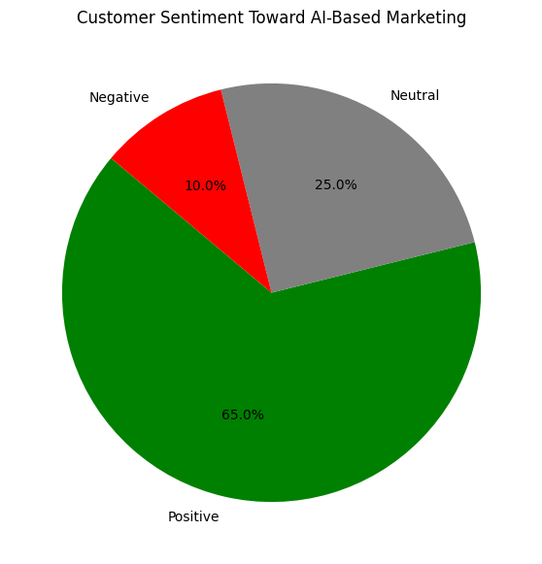
Figure 5.2 Customer Segmentation in AI-based marketing [19]

Based on the analysis, 65% of consumers have a positive perception of AI based marketing, 25% are neutral and only 10% have a negative perception. The existence of skepticism points to the importance of better disclosure, stronger data security, and ethical usage of AI technologies.
Conclusion
This chapter describes the strengths and weaknesses of the model developed, and recommendations for its improvement. It is therefore important to include more data sources, use real-time data, and apply more sophisticated AI methods in the model improvement process. Moreover, the development of an AI marketing app is seen as the next level of automation and enhancement of digital advertising. Organizations that embrace such a tool will be in a vantage position to enhance engagement, increase conversion rates and stay ahead of the competition in the digital world.

References
[1] B. Alguair, “Social Media Advertising: Platform Comparison and Recommendations,” Apr. 2021. Available: https://www.over-the-top.com/social-media-advertising-platform-comparison/.
[2] S. Kumar, S. U. Rahaman, P. R. A. Puchakayala, “Data-Driven Customer Segmentation: Advancing Precision Marketing through Analytics and Machine Learning Techniques,” J. Artif. Intell. Mach. Learn. Data Sci., vol. 13, pp. 1-15, Dec. 2021. DOI: 10.51219/JAIMLD/shafeeq-ur-rahaman/309.
[3] E. M. Hassib, A. I. El-Desouky, E. S. M. El-Kenawy, and S. M. El-Ghamrawy, “An Imbalanced Big Data Mining Framework for Improving Optimization Algorithms Performance,” IEEE Access, vol. 7, pp. 1-11, Nov. 2019. DOI: 10.1109/ACCESS.2019.2955983.
[4] S. R. Lodha, “Enhancing Marketing Strategy Development through Customer Segmentation Analysis Using Machine Learning Techniques,” ResearchGate, Mar. 2024. Available: https://www.researchgate.net/publication/385997182.
[5] H. Amnur, “Customer Relationship Management and Machine Learning Technology for Identifying the Customer,” Int. J. Inf. Vis., vol. 5, no. 2, pp. 35-50, Jun. 2017. DOI: 10.1109/ICIV.2017.25499904.
[6] J. Sammu, “Customer Segmentation and Marketing Strategies Using Machine Learning in Nigeria,” ResearchGate, Mar. 2024. Available: https://www.researchgate.net/publication/386334541.
[7] M. Majka, “Implementing Customer Segmentation in Marketing,” ResearchGate, Apr. 2024. Available: https://www.researchgate.net/publication/386242943.
[8] V. Gallego, J. Lingan, A. Freixes, A. A. Juan, and C. Osorio, “Applying Machine Learning in Marketing: An Analysis Using the NMF and k-Means Algorithms,” Information, vol. 15, no. 7, p. 368, Jul. 2024. DOI: 10.3390/info15070368.
[9] V. Duarte, S. Zuniga-Jara, and S. Contreras, “Machine Learning and Marketing: A Systematic Literature Review,” IEEE Access, vol. 10, pp. 145678-145691, Sep. 2022. DOI: 10.1109/ACCESS.2022.3202896.
[10] T. Verdonck, B. Baesens, M. Óskarsdóttir, and S. V. Broucke, “Special Issue on Feature Engineering in Machine Learning,” Mach. Learn. J., vol. 125, no. 4, pp. 1-15, Feb. 2024. DOI: 10.1007/s10994-021-06042-2.
[11] Q. Abbas, “The Impact of Personalization Strategies on Consumer Engagement and Conversion Rates in Digital Marketing,” ResearchGate, Jan. 2024. Available: https://www.researchgate.net/publication/377538425.
[12] G. C. Saha, S. S. Yerasuri, and H. Saha, “The Impact of Artificial Intelligence on Business Strategy and Decision-Making Processes,” ResearchGate, vol. 10, pp. 85-97, May 2023. DOI: 10.52783/eel.v13i3.386.
[13] D. S. Khafaga, A. A. Alhussan, E. S. M. El-Kenawy, and A. E. Takieldeen, “Meta-heuristics for Feature Selection and Classification in Diagnostic Breast Cancer,” Comput. Mater. Continua, vol. 74, no. 8, pp. 5254-5271, Jul. 2022. DOI: 10.32604/cmc.2022.029605.
[14] C. Uzcátegui and D. Zaldumbide, “Business Strategies in the Digital Age: An Analysis of the Use of Social Media in Today’s Ecuadorian Economy,” Rev. Cient. Cienc. Tecnol., vol. 7, no. 2, pp. 105-119, Feb. 2024. DOI: 10.51247/st.v7i2.414.
[15] A. M. Zaki, N. Khodadadi, and W. H. Lim, “Predictive Analytics and Machine Learning in Direct Marketing for Anticipating Bank Term Deposit Subscriptions,” Am. J. Bus. Oper. Res., vol. 11, no. 1, pp. 1-14, Mar. 2024. DOI: 10.54216/AJBOR.110110.
[16] R. Aqrabawi, B. Ismaeel, and K. K. Alafi, “The Impact of AI-Driven Consumer Insights on Targeted Marketing and Customer Retention Strategies,” Pak. J. Life Soc. Sci., vol. 12, no. 4, pp. 1-16, Jan. 2024. Available: https://www.researchgate.net/publication/385978626.
[17] M. Estevez, M. T. Ballestar, and J. Sainz, “A Primer on Out-of-the-Box AI Marketing Mix Models,” IEEE Trans. Eng. Manag., vol. 71, no. 2, pp. 255-270, Apr. 2024. DOI: 10.1109/TEM.2024.3519172.
[18] C. James and M. Yusuff, “AI-Driven Strategies for Marketing Campaign Optimization,” ResearchGate, Mar. 2024. Available: https://www.researchgate.net/publication/387947152.
[19] P. Rymarczyk, M. Rutkowski, and T. Smutek, “Advanced Methods for Target Audience Identification: Enhancing Marketing Strategies through Machine Learning and Data Analytics,” J. Mod. Sci., vol. 34, no. 3, pp. 189-205, Feb. 2024. DOI: 10.13166/jms/191180.
[20] V. Pothuri, “AI-Driven Marketing Automation: Shaping Tomorrow’s Marketing Strategies,” TechBullion, Jan. 2023. Available: https://www.researchgate.net/publication/385856669.
[21] M. K. Pasupuleti, “Transforming Digital Marketing with AI: Strategies for Personalized Content and Ethical Advertising,” Int. J. Acad. Ind. Res. Innov., vol. 18, no. 2, pp. 98-112, Feb. 2024. DOI: 10.62311/nesx/66296.
[22] E. William, “Retail Marketing Innovations: AI-Driven Campaign Management,” Columbia Univ., Jan. 2024. Available: https://www.researchgate.net/publication/387730528.
[23] S. Yella, “AI-Driven Content Creation and Personalization: Revolutionizing Digital Marketing Strategies,” IRJET, vol. 11, no. 3, pp. 225-238, Apr. 2024. Available: https://www.researchgate.net/publication/382296218.
[24] M. Singh, “Machine Learning in Marketing Analytics,” Int. J. Enhanc. Res. Manag. Comput. Appl., vol. 20, no. 1, pp. 75-91, Jan. 2024. DOI: 10.55948/IJERMCA.2024.0410.

